Devin Hardy

Documentation of my JOurney

Table of Contents

**1.** **Website Description & Purpose** 2

**2.** **Stakeholders & Audience** 2

**2.1 Stakeholders** 2

**2.2 Audience** 2

**3.** **Sitemap** 2

**4.** **Wireframe** 4

**5.** **DOM** 19

**6.** **Live Site & Validation** 20

**6.1 Live Site** 20

**6.2 Validation** 28

**7.** **Accessibility** 36

**7.1** **Web Accessibility** 36

**7.2** **Mobile Accessibility** 36

**8.** **Reflection** 45

**9.** **References** 46

# **Website Description & Purpose**

# **Stakeholders & Audience**

The stakeholders are affected by what is decided and shown on the website. Those that are affected are the government, employers, and me.

The audience will be employers, and individuals who decide to visit the site.

## **2.1 Stakeholders**

As mentioned before the stakeholders of the site are the government, employers, and me. The government could be affected by me working for them if I’m contracted to hired to work for them. Employers are affected in the same manner as the government, but instead I would be working for them. Lastly, I would be affected by anyway who visits the site and decides to reach out to me.

## **2.2 Audience**

The audience as mentioned before will be employers, and individuals who decide to visit the site. It is very difficult to figure out the demographic of the audience of this site. But with some assumptions the demographic from the audience is roughly split in half for the gender distribution. The age distribution would be spread across the board but there might be a focus 25-44 years old who have the highest chance of looking at the sight.

# **Sitemap**

So far, the website will have 15 pages. It will have a home page that tells the story of my learning process of web development during the 2023 Spring Semester and will point to pages that I have selected that best highlight what I learned during that point in time. So far, the site is very simple but has plenty of potential to be upgraded further.

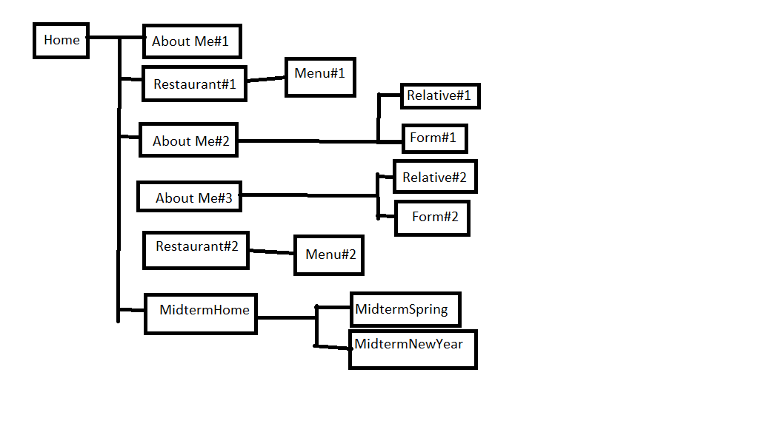

Figure 3.1 (Sitemap)

# **Wireframe**

The website will attempt to follow the wireframes that will be displayed in figures 4.1-15. Figure 4.1 is the wireframe for the home site that will tell my story during the course.

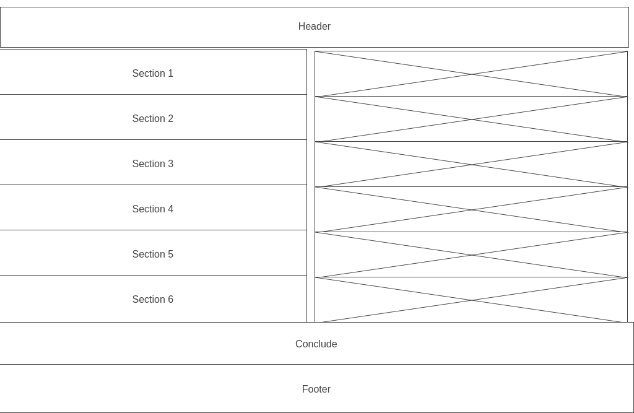

Figure 4.1 (Home)

Figure 4.2 is what my first page looked like.

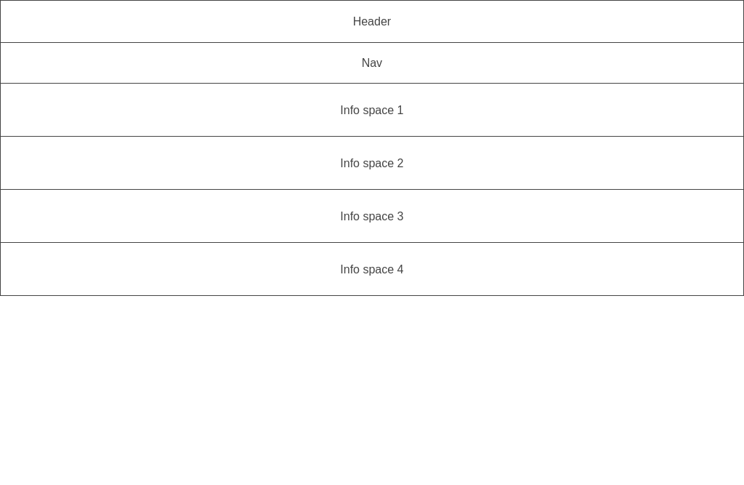

Figure 4.2 (First page)

Figures 4.3 and 4.4 will display the Home of the first attempt at the restaurant and menu.

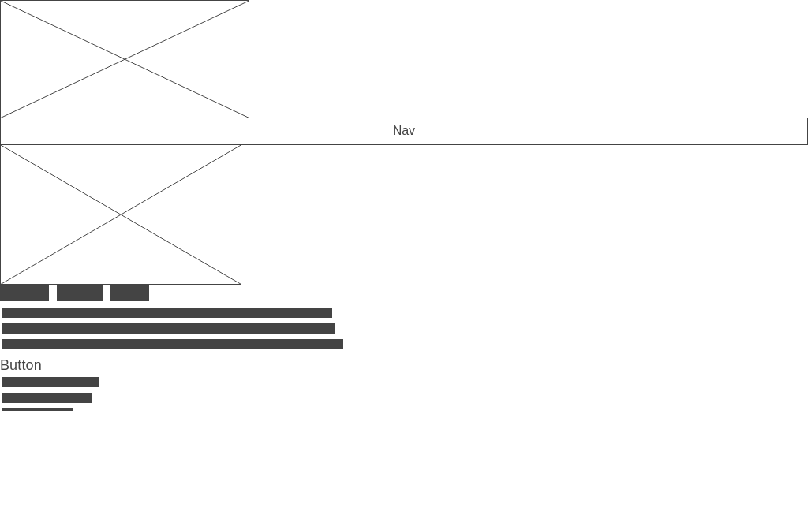

Figure 4.3 (Restaurant 1)

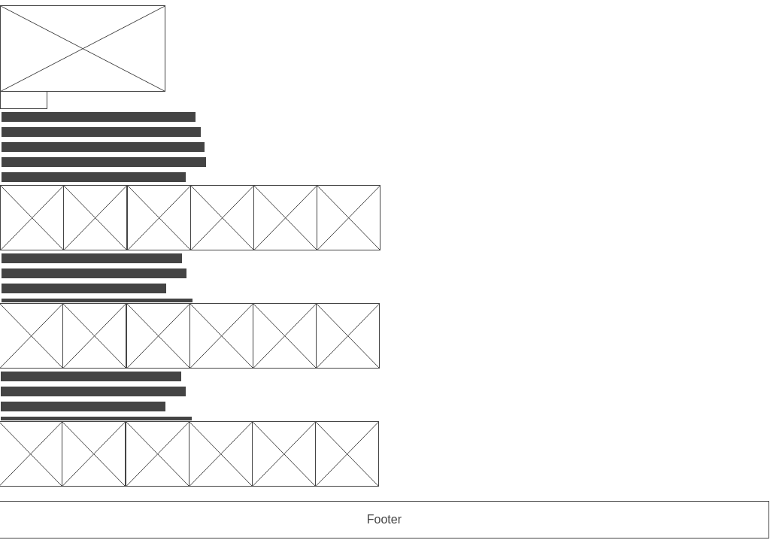

Figure 4.4 (Menu 1)

Figures 4.5-7 are the wireframes related to my Midterm project.

Figure 4.5 (Midterm Home)

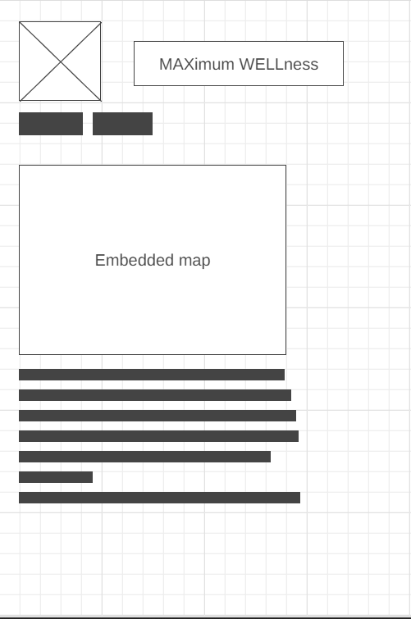

Figure 4.6 (Midterm New Year)

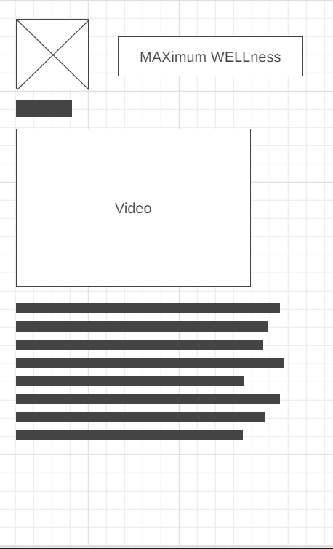

Figure 4.7 (Midterm Spring Break)

Figures 4.8-10 are the sites plus CSS with format changes and images.

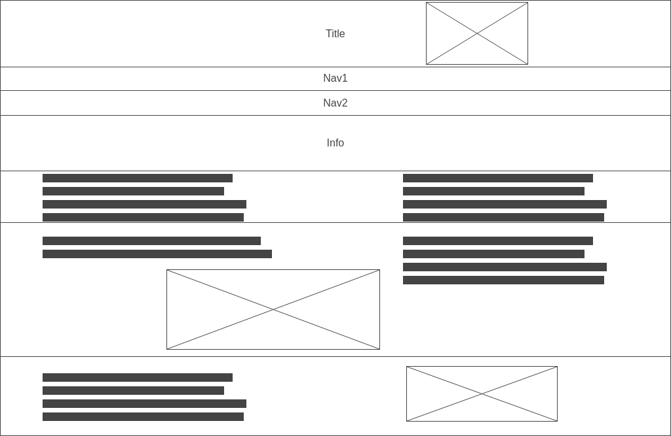

Figure 4.8 (About Me1)

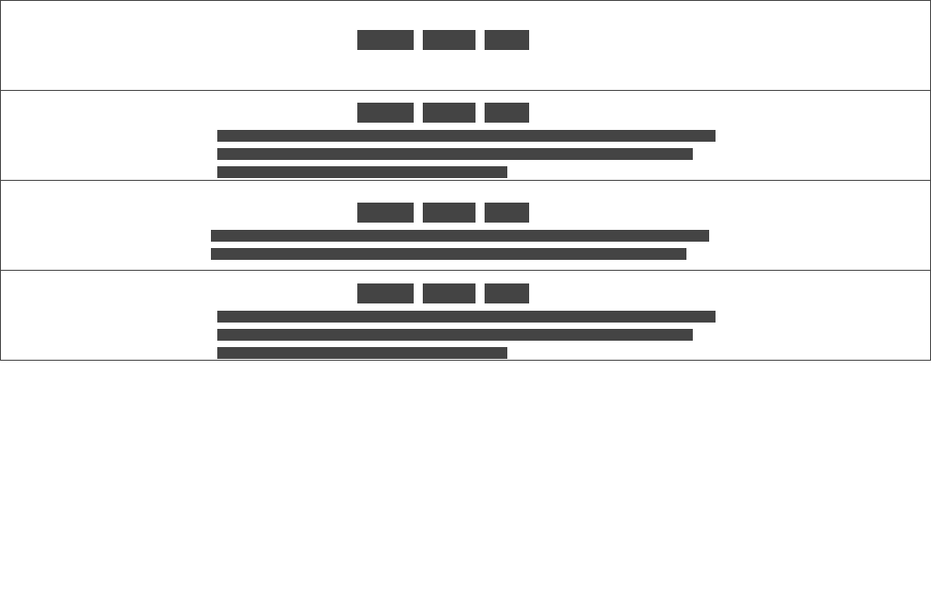

Figure 4.9 (Relative Info)

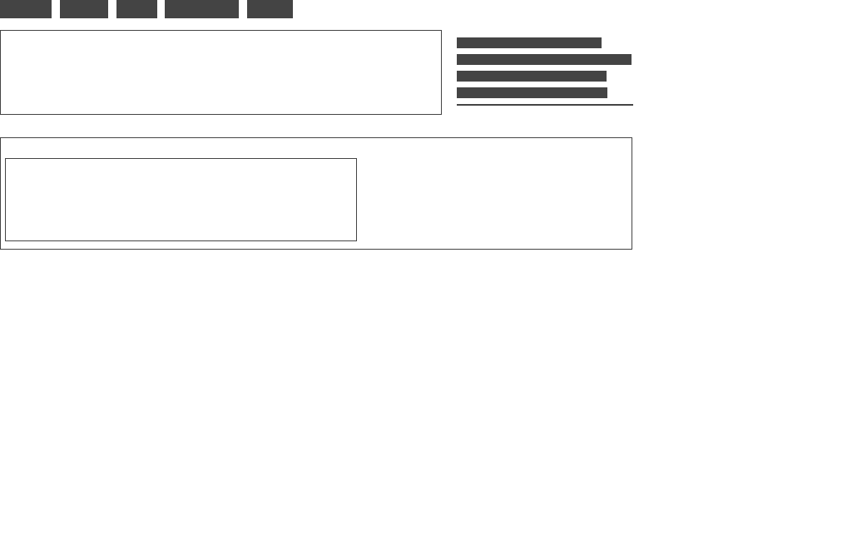

Figure 4.10 (Form Page)

Figures 4.11-13 Doesn’t change from the previous figures as I will only have added some interactivity on the webpages.



Figure 4.11 (About Me2)



Figure 4.12 (Relative2)



Figure 4.13 (Form2)

Figures 4.14 and 4.15 are the last wireframes related to this story and they cover the upgraded Restaurant page and Menu Page.

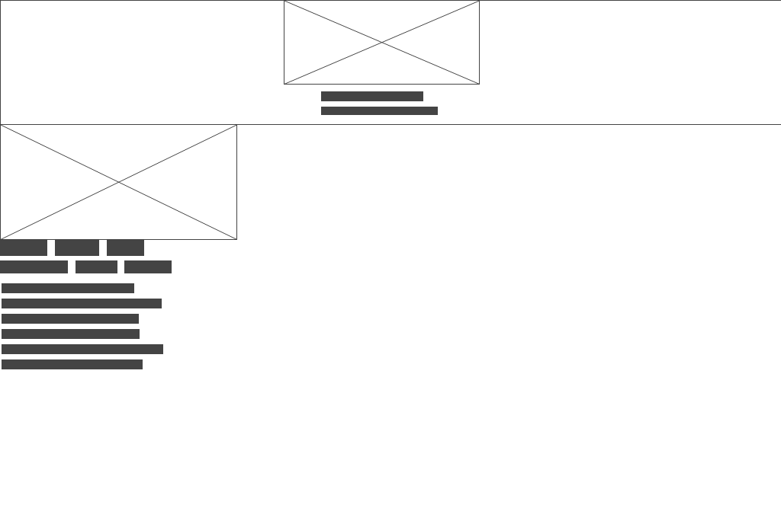

Figure 4.14 (Restaurant2)

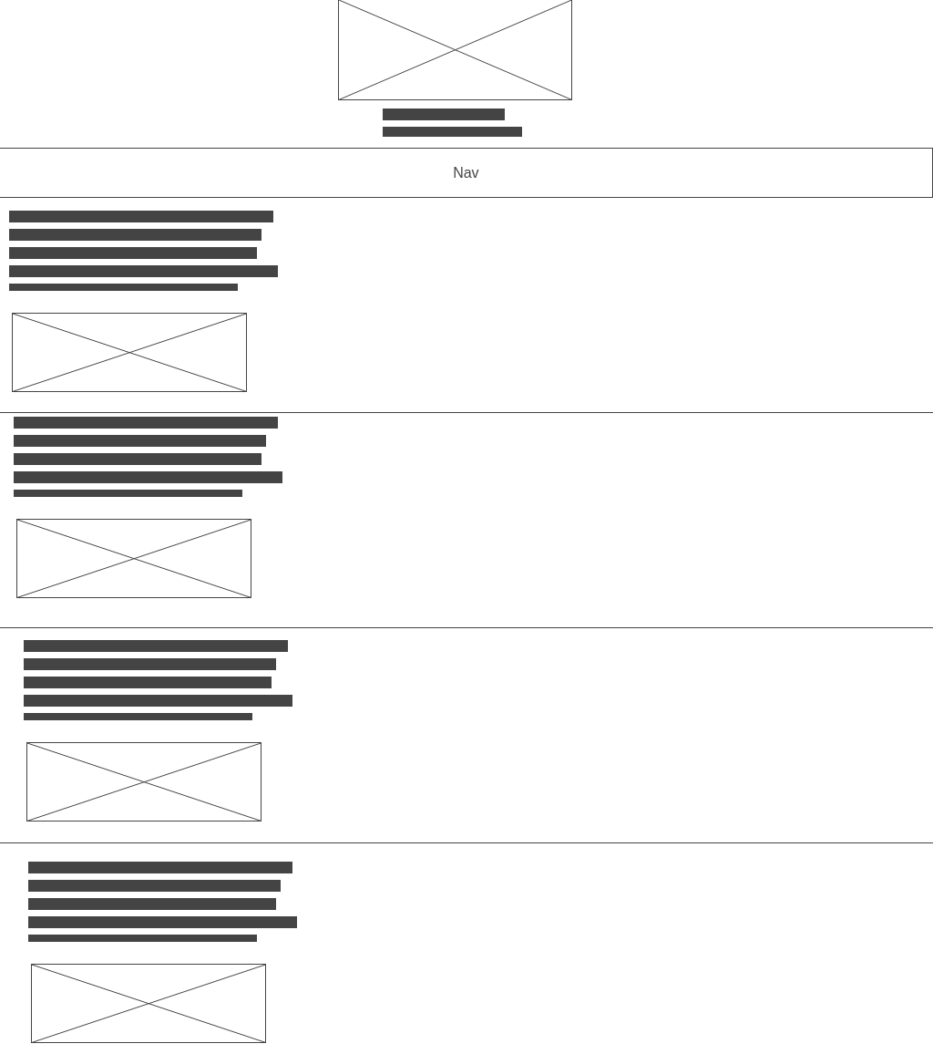

Figure 4.15 (Menu2)

# **DOM**

A DOM is a model of the HTML format of a page and figure 5.1 shows what the setup of the HTML file looks like. It displays the way it is formatted and divided.

Figure 5.1 (DOM)

# **Live Site & Validation**

This section is very important it shows that the site is both live and has been validated.

There will be many images and figures but each will be explained. A rough explanation is that each image is a screenshot of either proof that a page of the website is live or proof that a page has been validated.

## **6.1 Live Site**

Figure 6.1.1 – 6.1.3 show that the website is currently live on the web and can be accessed. Figure 5.1.1 shows the home page of the website that links to everything.

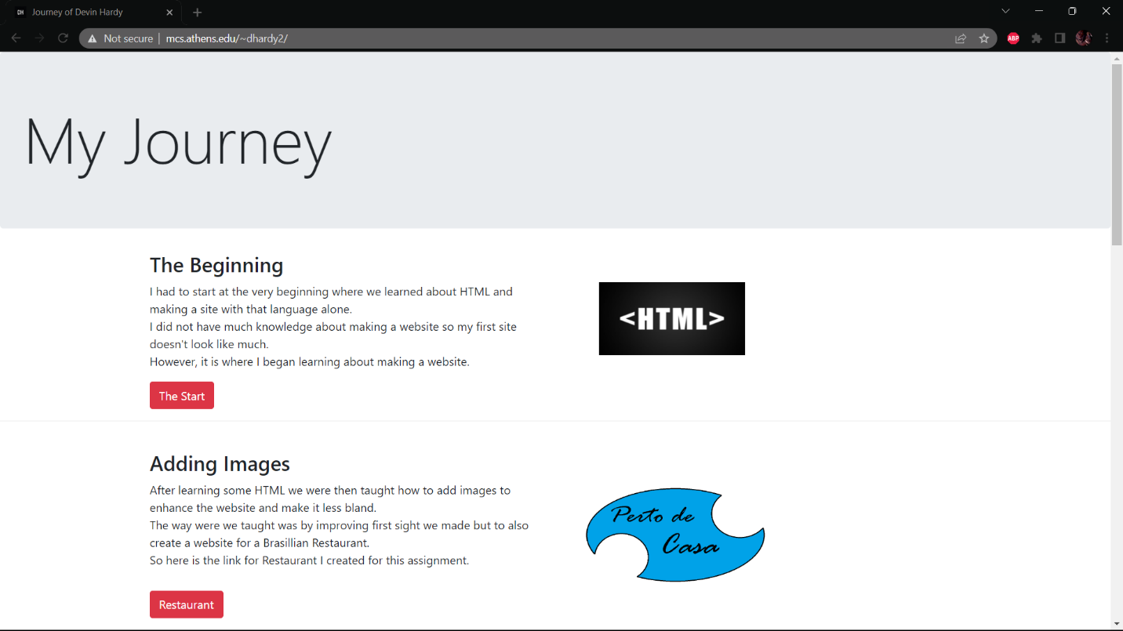

Figure 6.1.1 (Home Site)

Figure 5.1.2 displays the live site of my first web page.

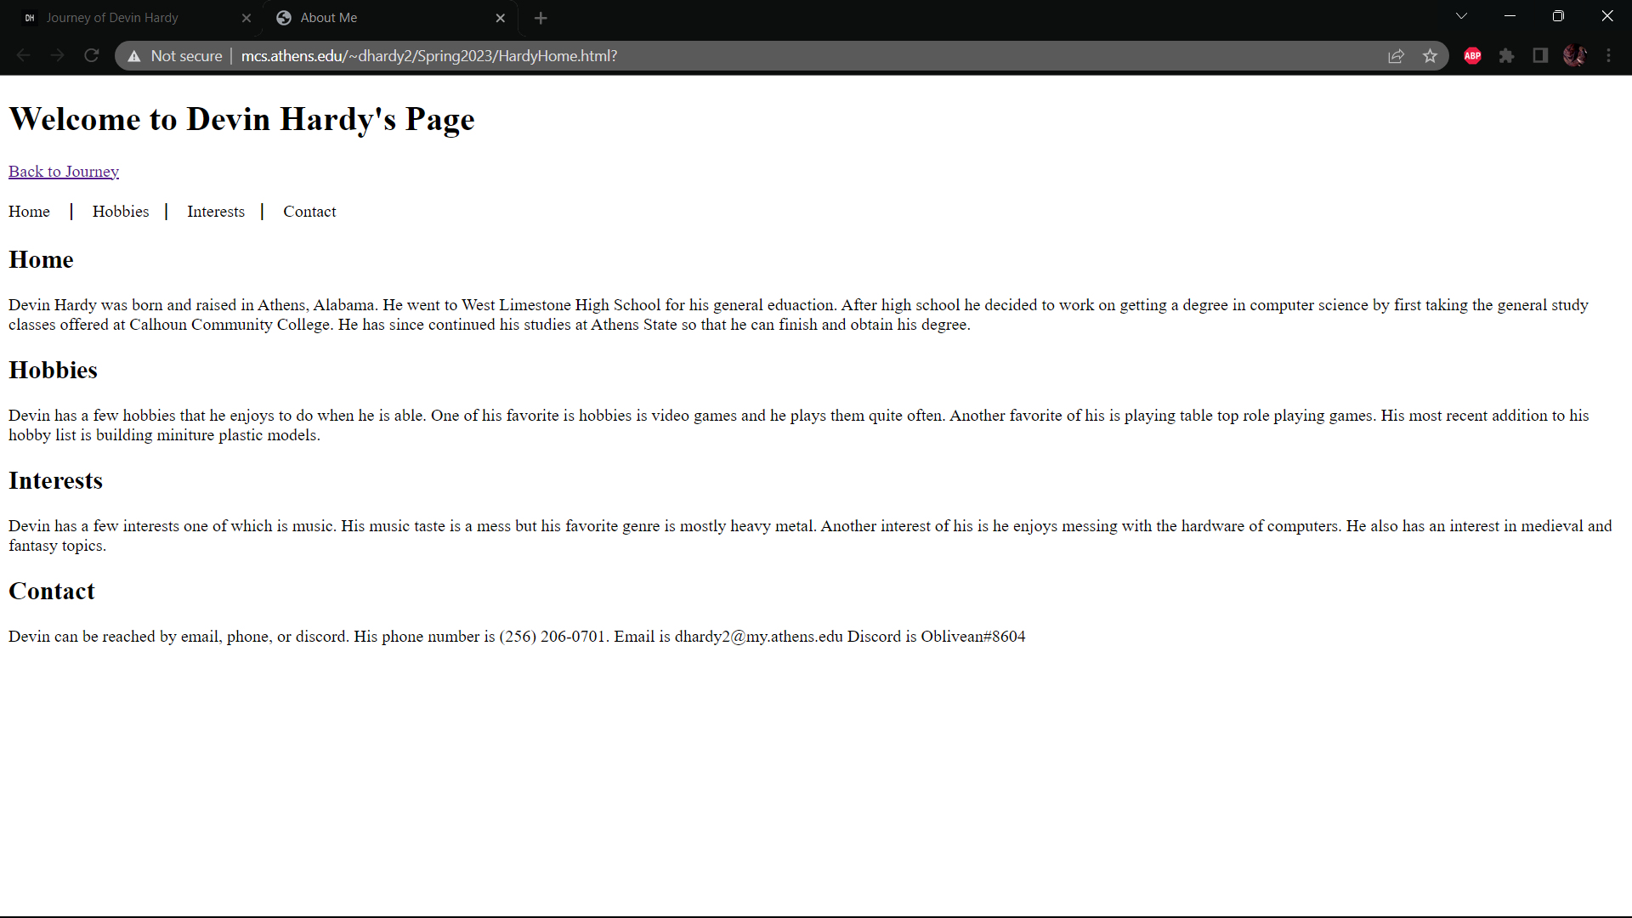

Figure 6.1.2 (First website)

Figures 6.1.3 and 6.1.4 show the first version of my Restaurant website.

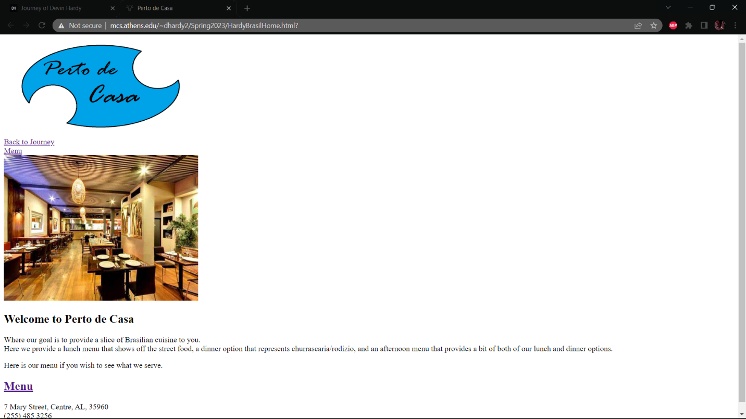

Figure 6.1.3 (Restaurant Version 1)

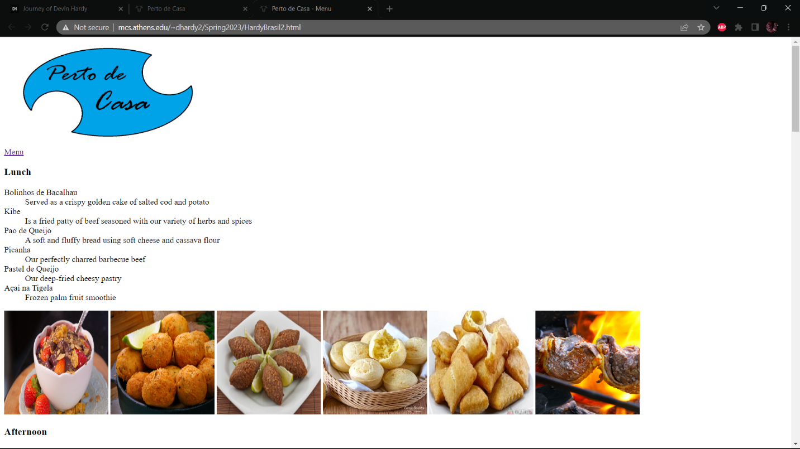

Figure 6.1.4 (Menu Version 1)

Figures 6.1.5-7 show that my midterm homepage, New Year site, and Spring Break site are all live and out on the web.

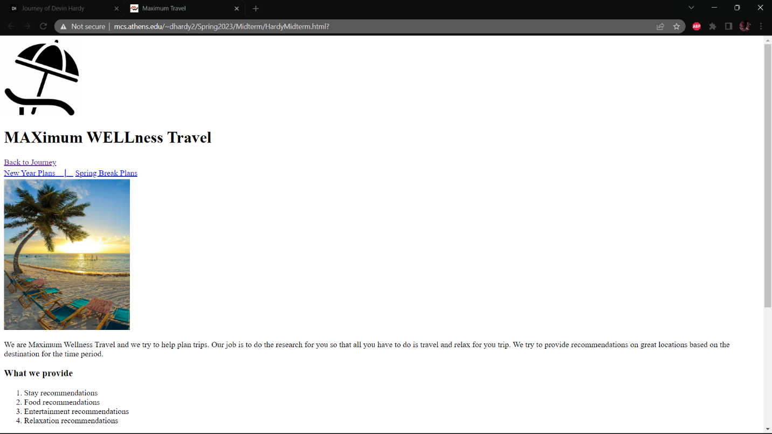

Figure 6.1.5 (Midterm Home)

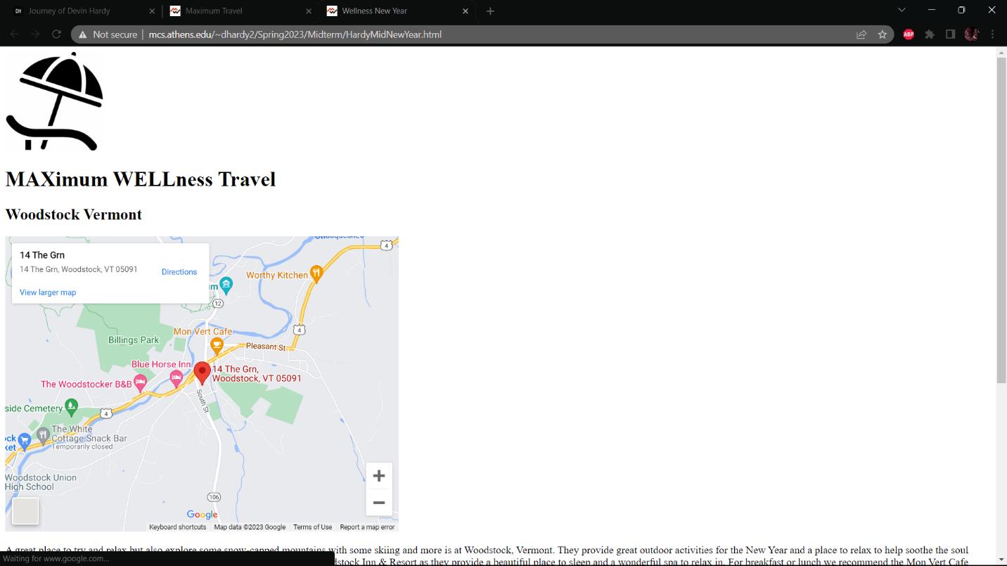

Figure 6.1.6 (New Year Site)

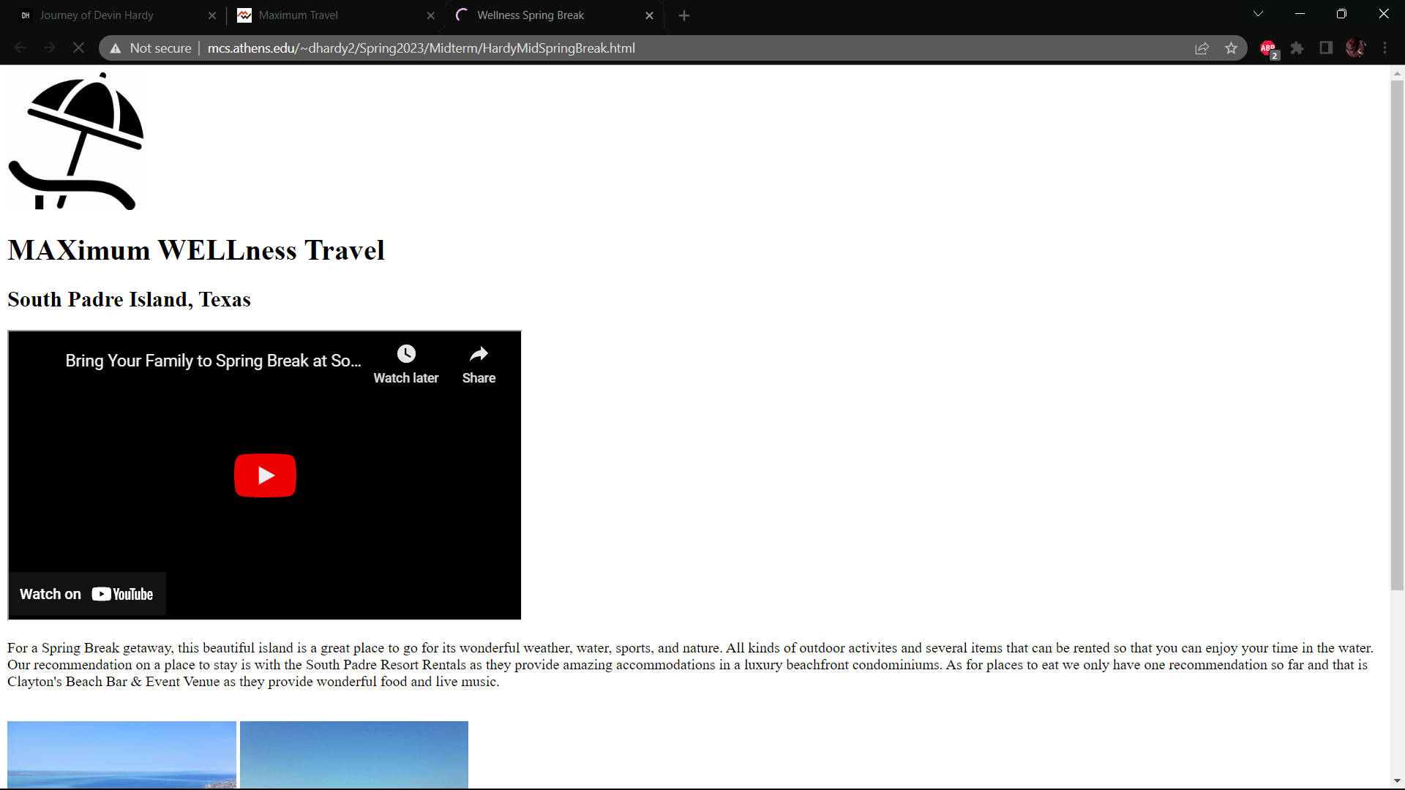

Figure 6.1.7 (Spring Break Site)

Figures 6.1.8-10 display the live site of when I was learning CSS.

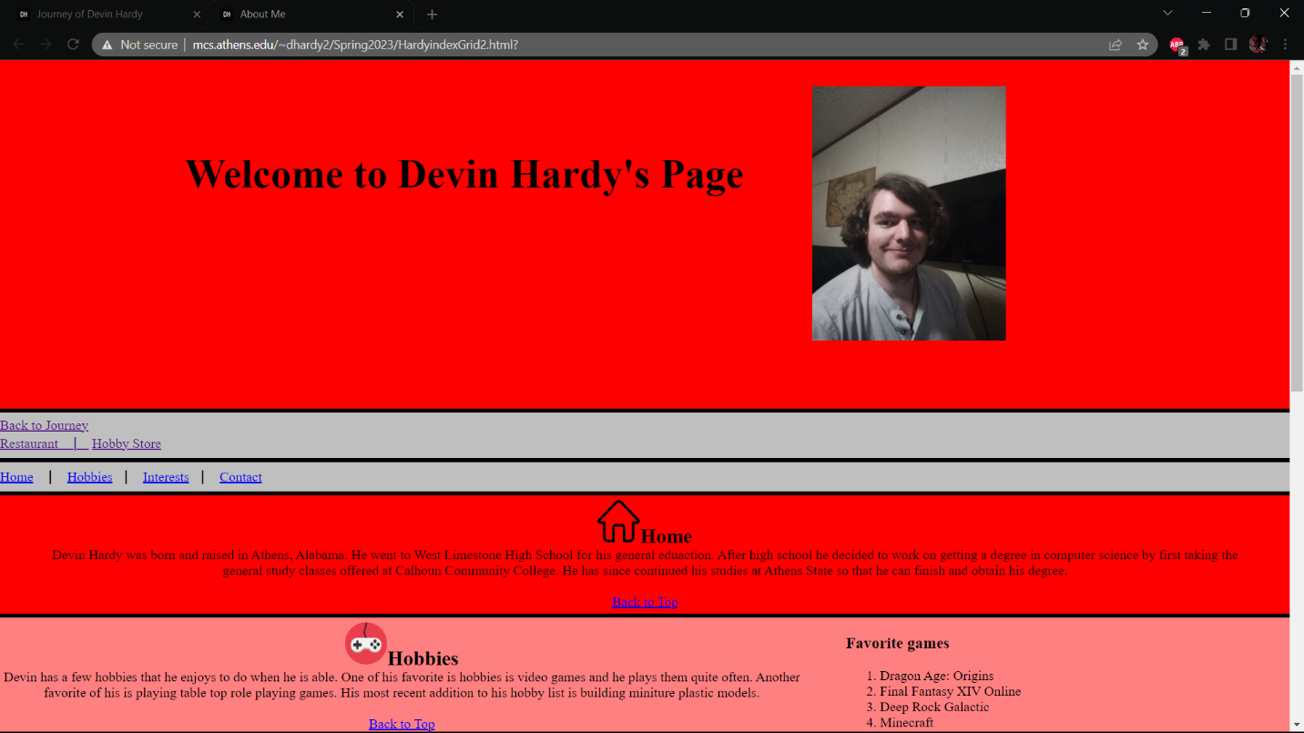

Figure 6.1.8 (Spring Break Site)

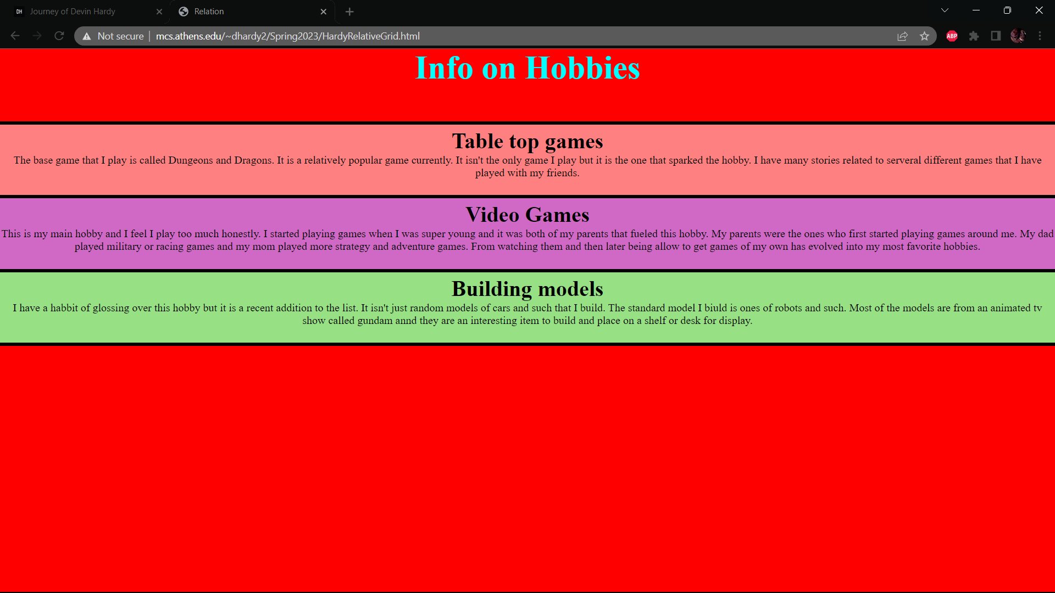

Figure 6.1.9 (Spring Break Site)

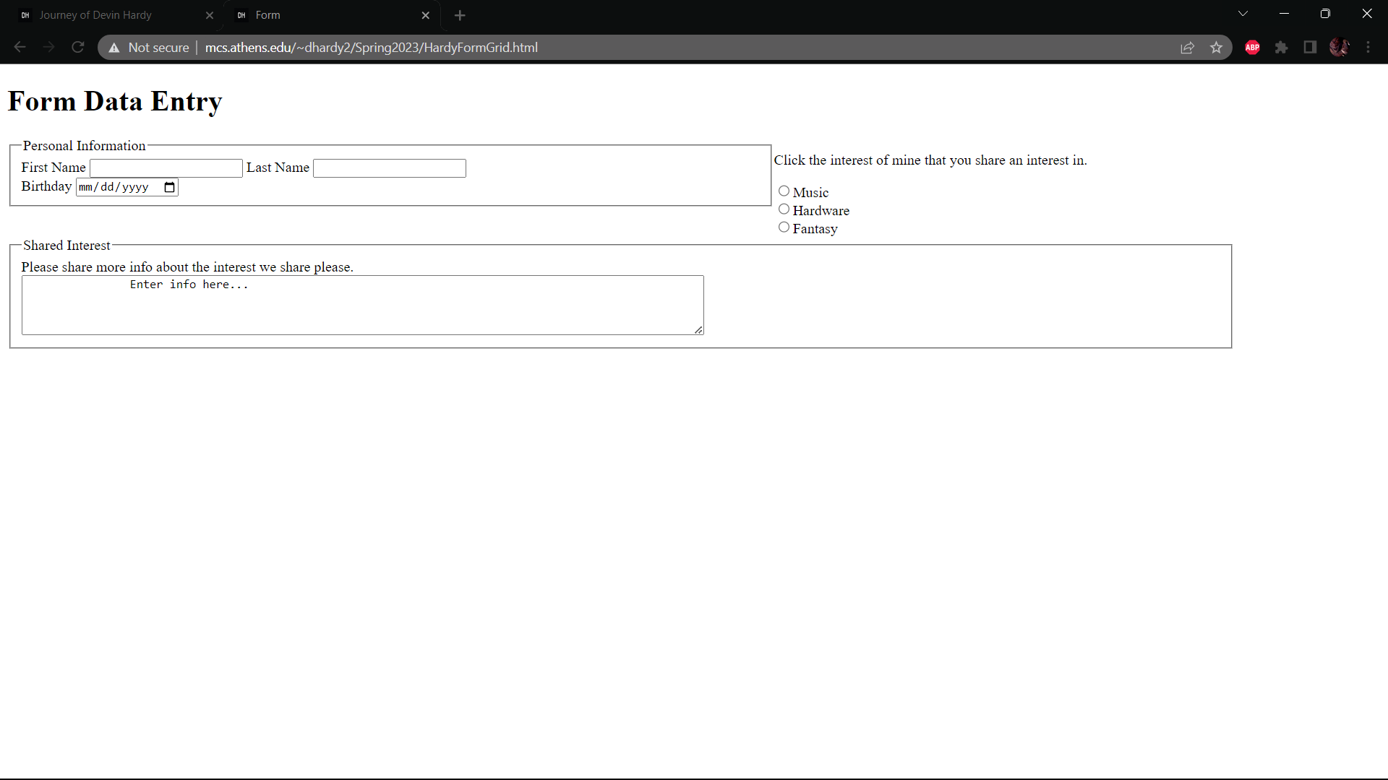

Figure 6.1.10 (Spring Break Site)

Figures 6.1.11-13 will more than likely look very similar to 6.1.8-10 but there are some differences to them. Most differences are due to learning JavaScript and JQuery so most changes allow for quick additions when being viewed live.

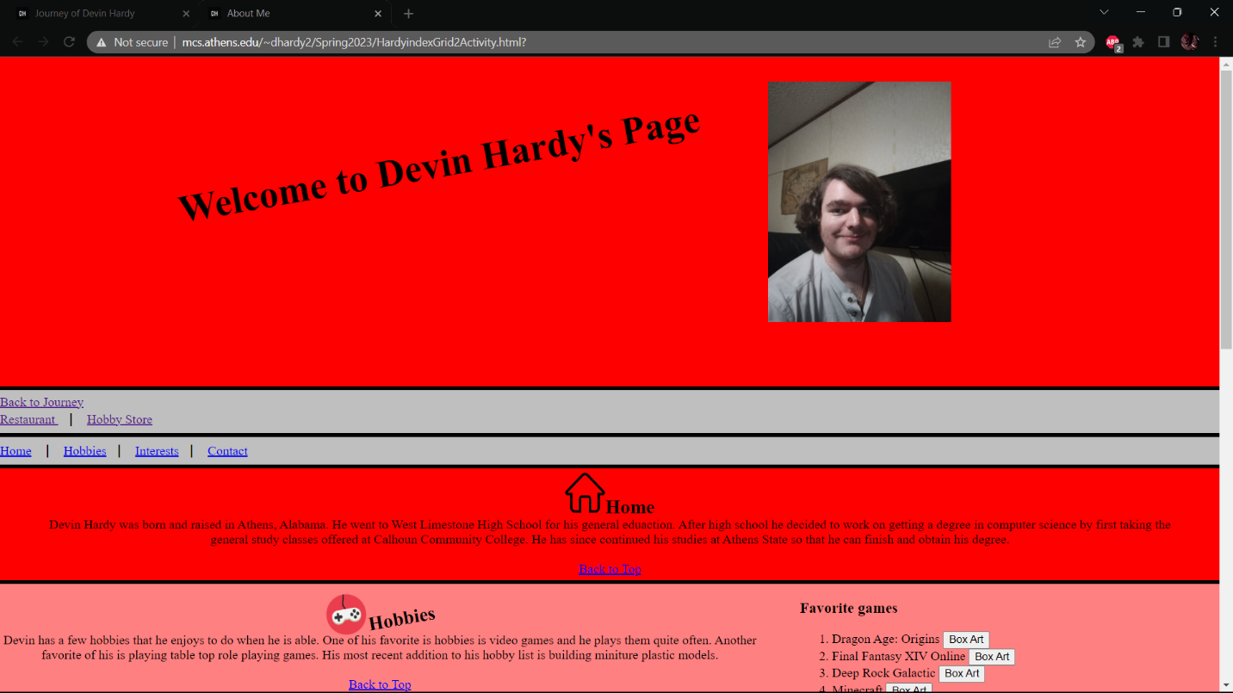

Figure 6.1.11 (Spring Break Site)

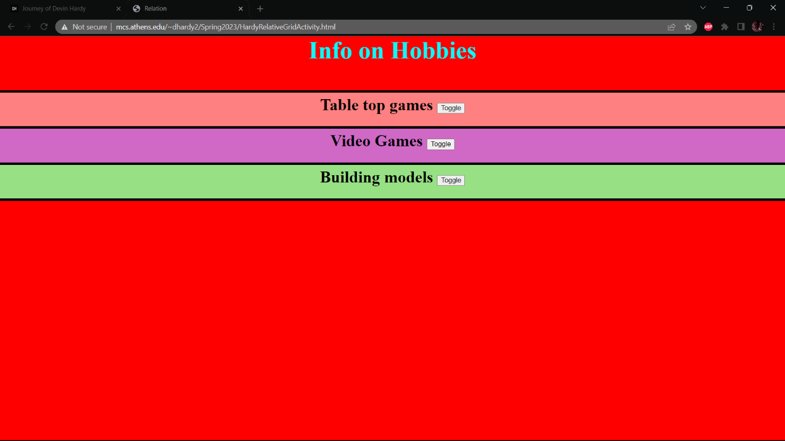

Figure 6.1.12 (Spring Break Site)

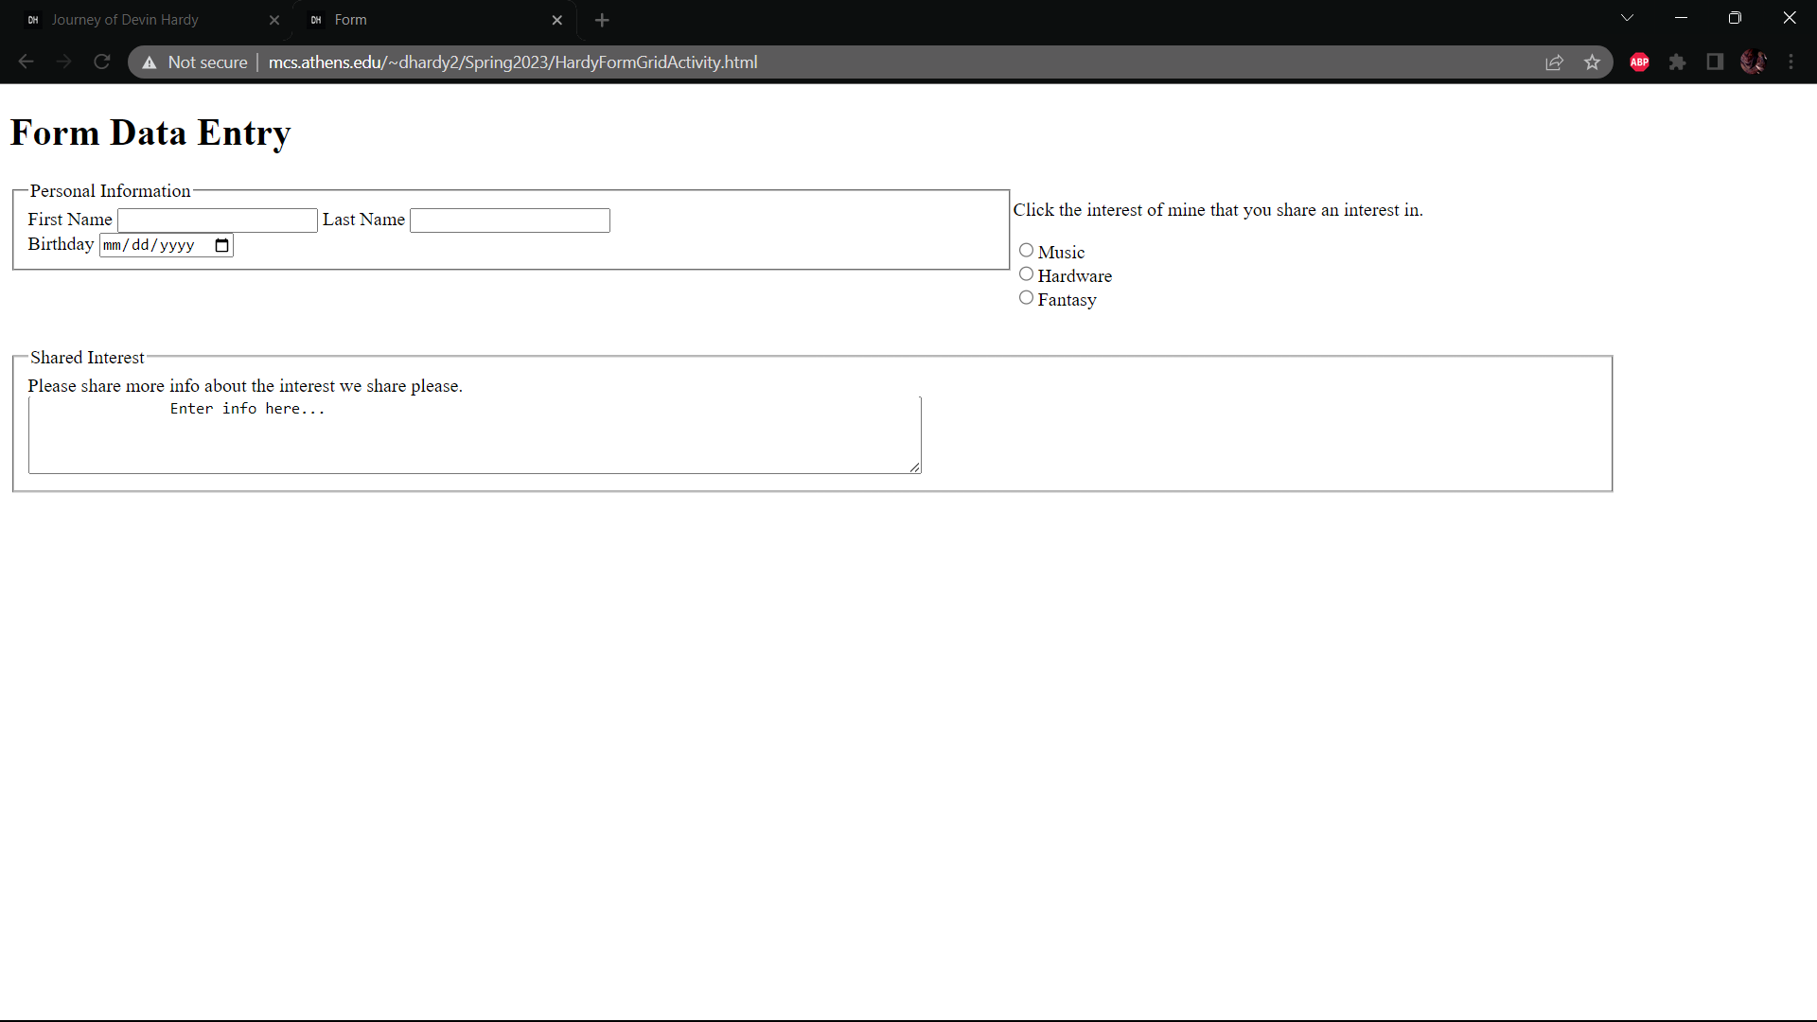

Figure 6.1.13 (Spring Break Site)

The last two figures 6.1.14 and 6.1.15 are the second version of my restaurant pages but with the addition of BootStrap.

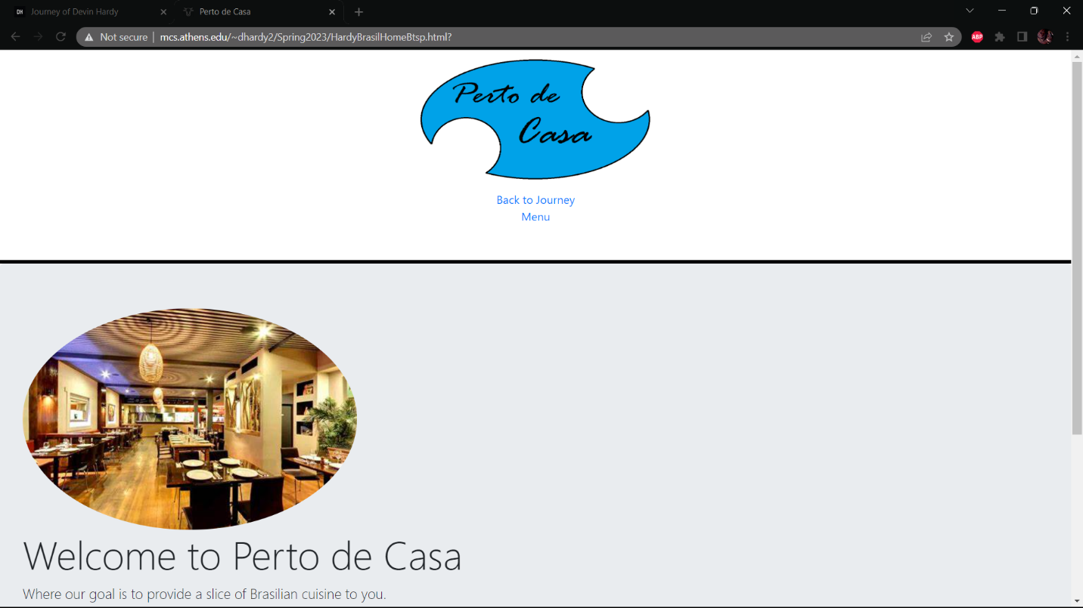

Figure 6.1.14 (Spring Break Site)

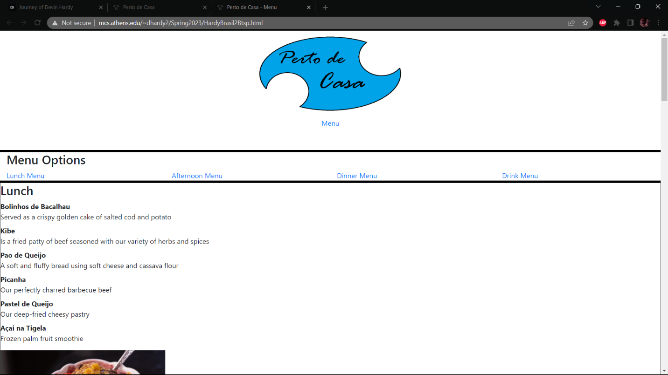

Figure 6.1.15 (Spring Break Site)

## **6.2 Validation**

All the of Figures 6.2.1-15 will show that there are no errors or warnings for the live websites and that they are validated. All sites have no issues in the code and can be displayed when searching for them.

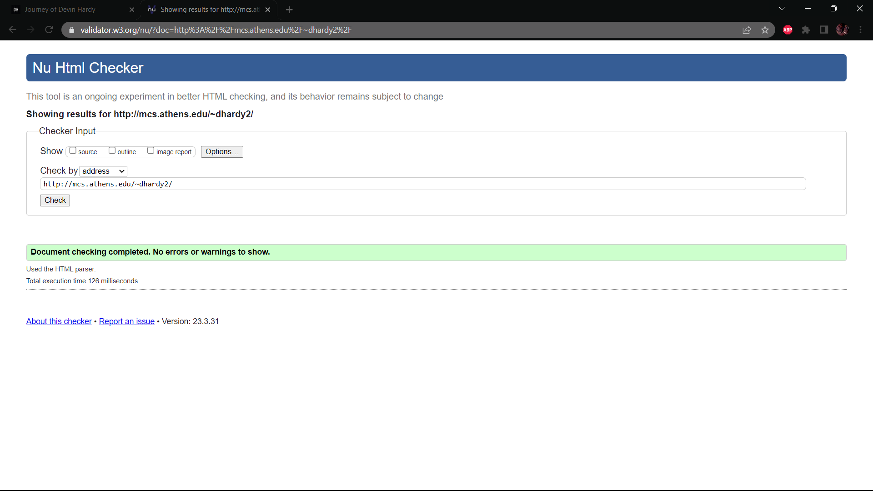

Figure 6.2.1 Home Validation

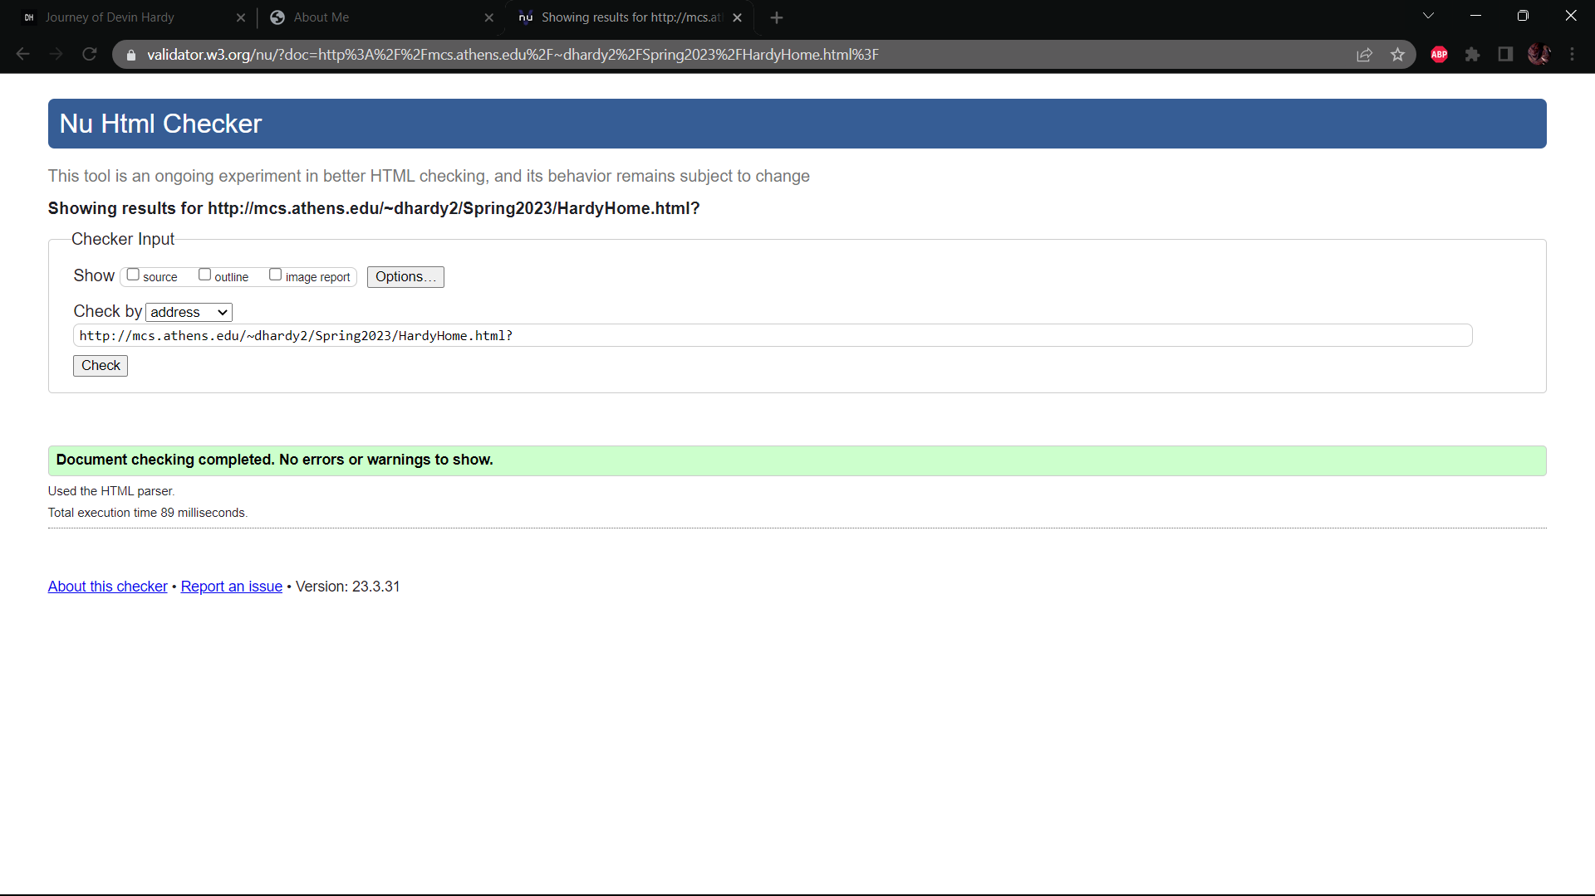

Figure 6.2.2 First Page Validation

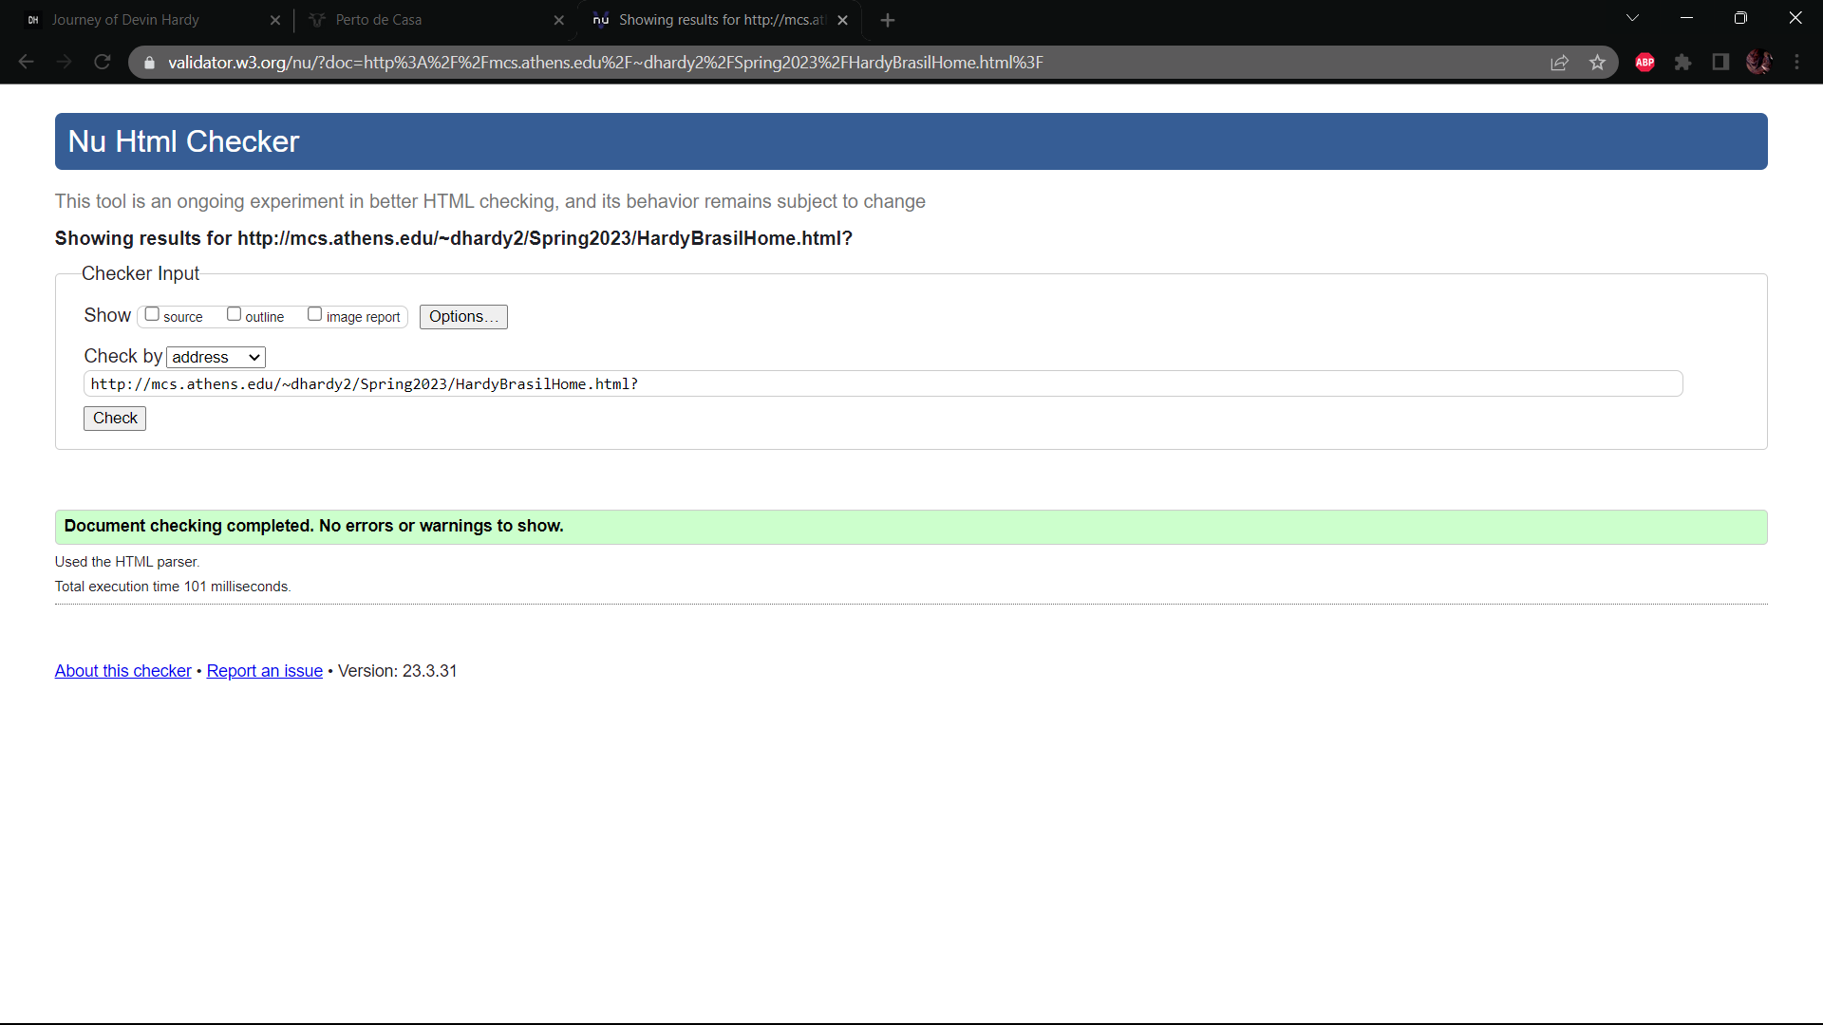

Figure 6.2.3 Restaurant V1 Validation

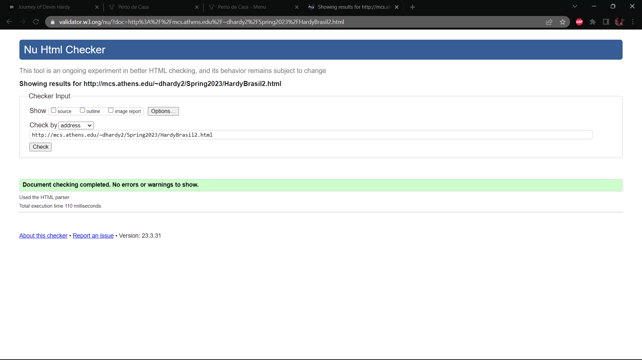

Figure 6.2.4 Menu V1 Validation

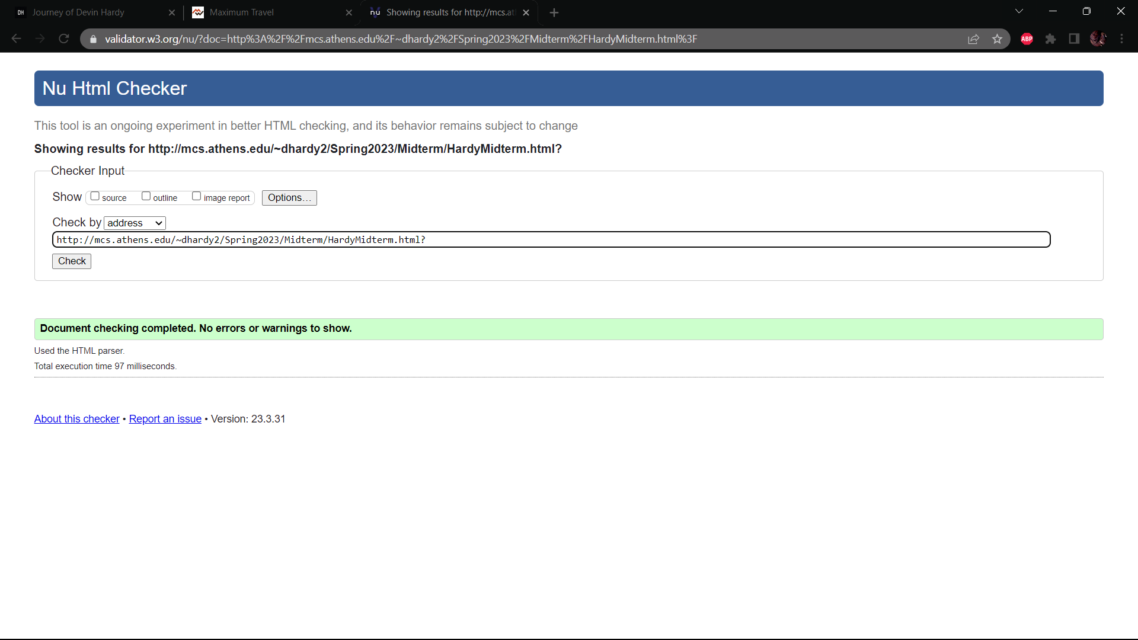

Figure 6.2.5 Midterm Home Validation

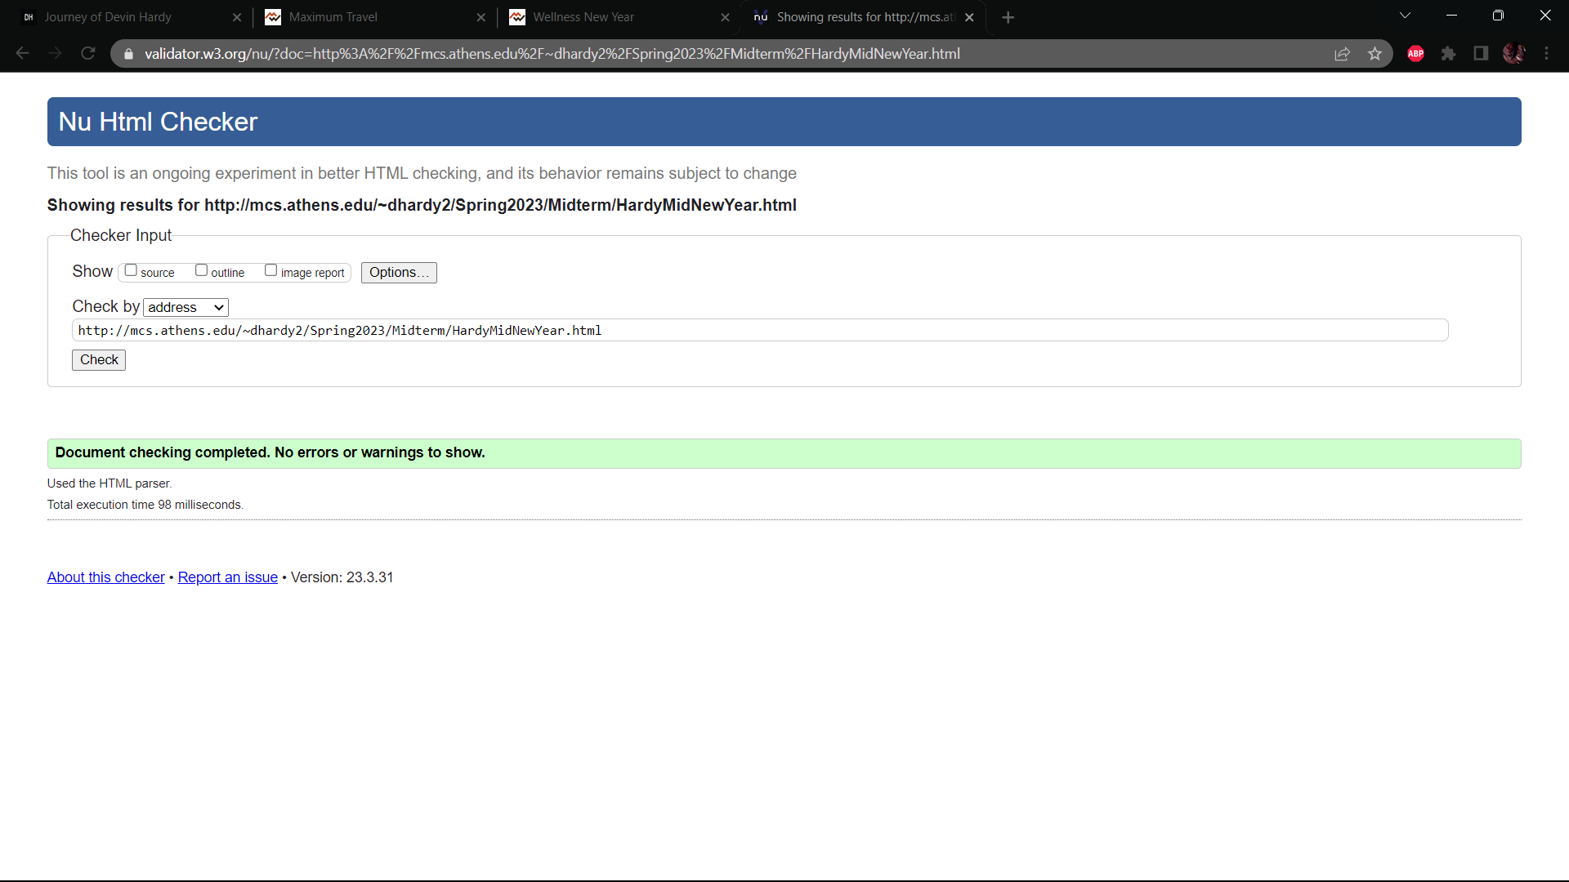

Figure 6.2.6 New Year Validation

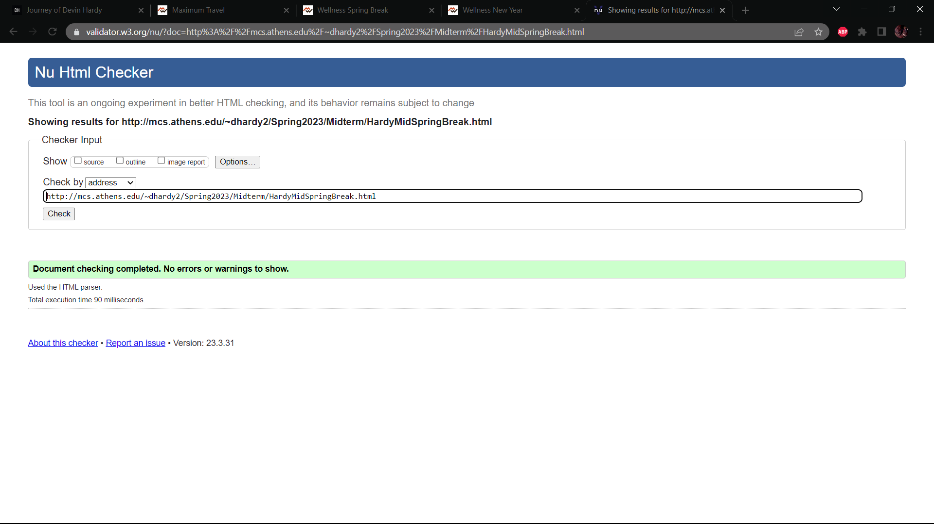

Figure 6.2.7 Spring Break Validation

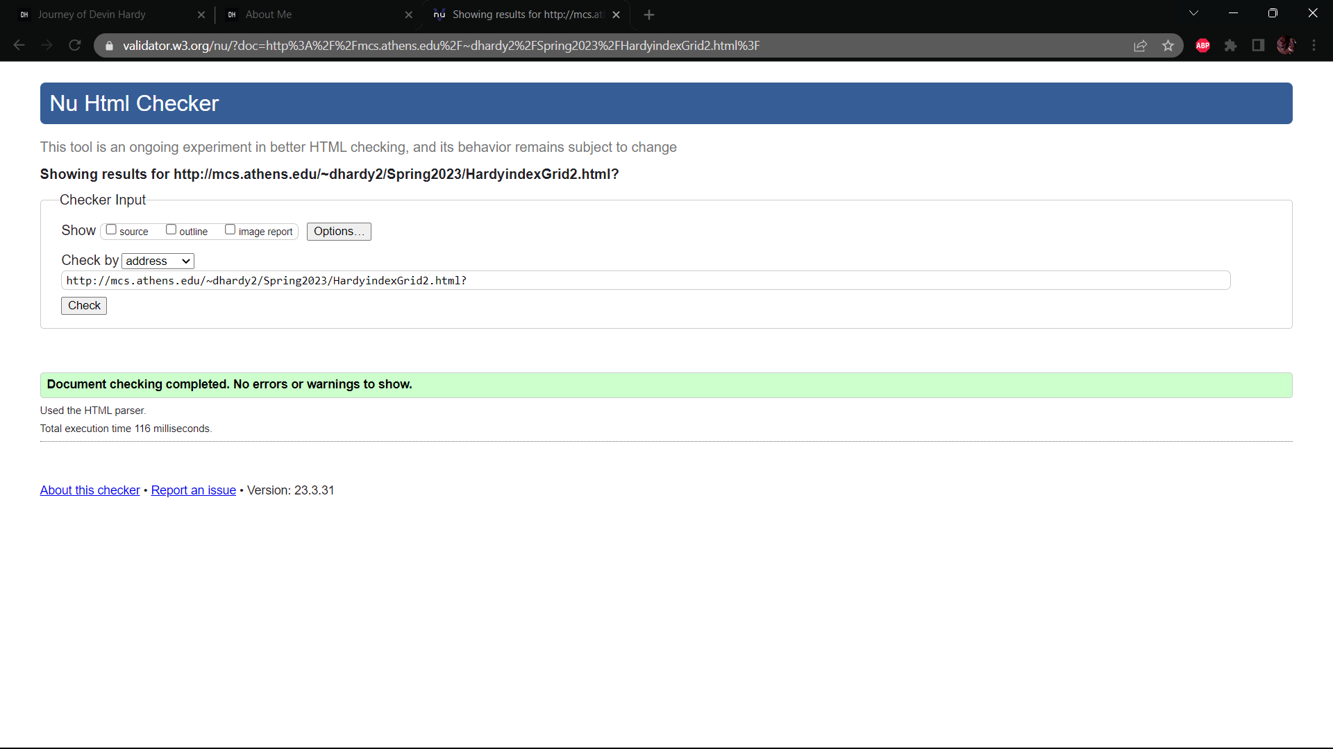

Figure 6.2.8 CSS Learning Validation

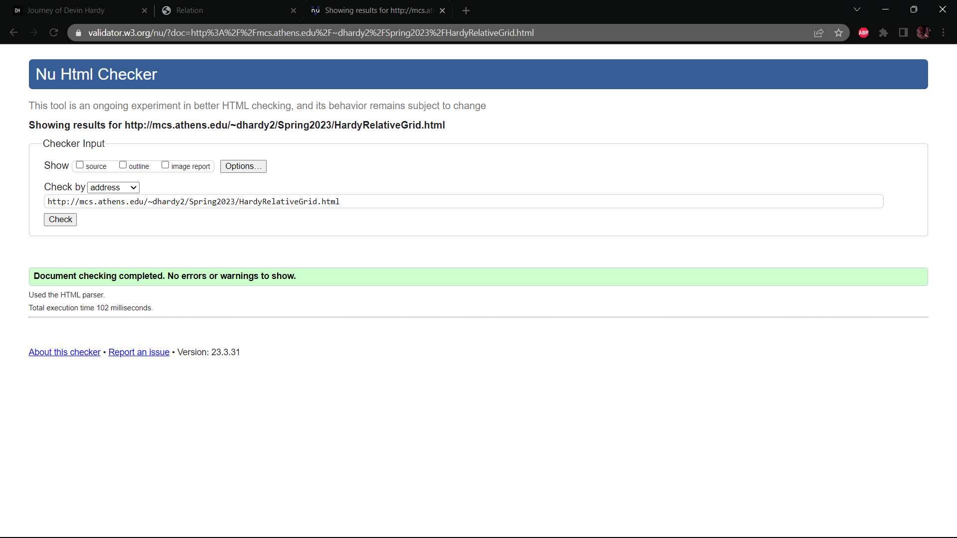

Figure 6.2.9 CSS Learning 2 Validation

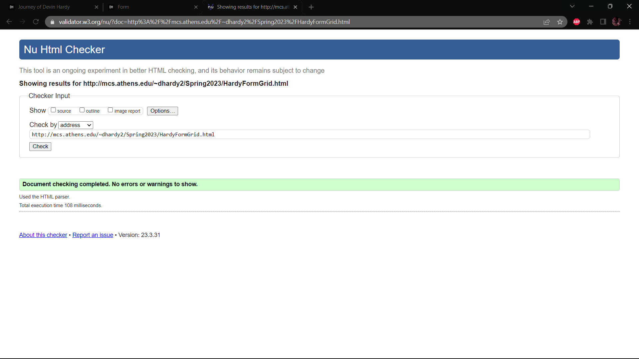

Figure 6.2.10 CSS Learning 3 Validation

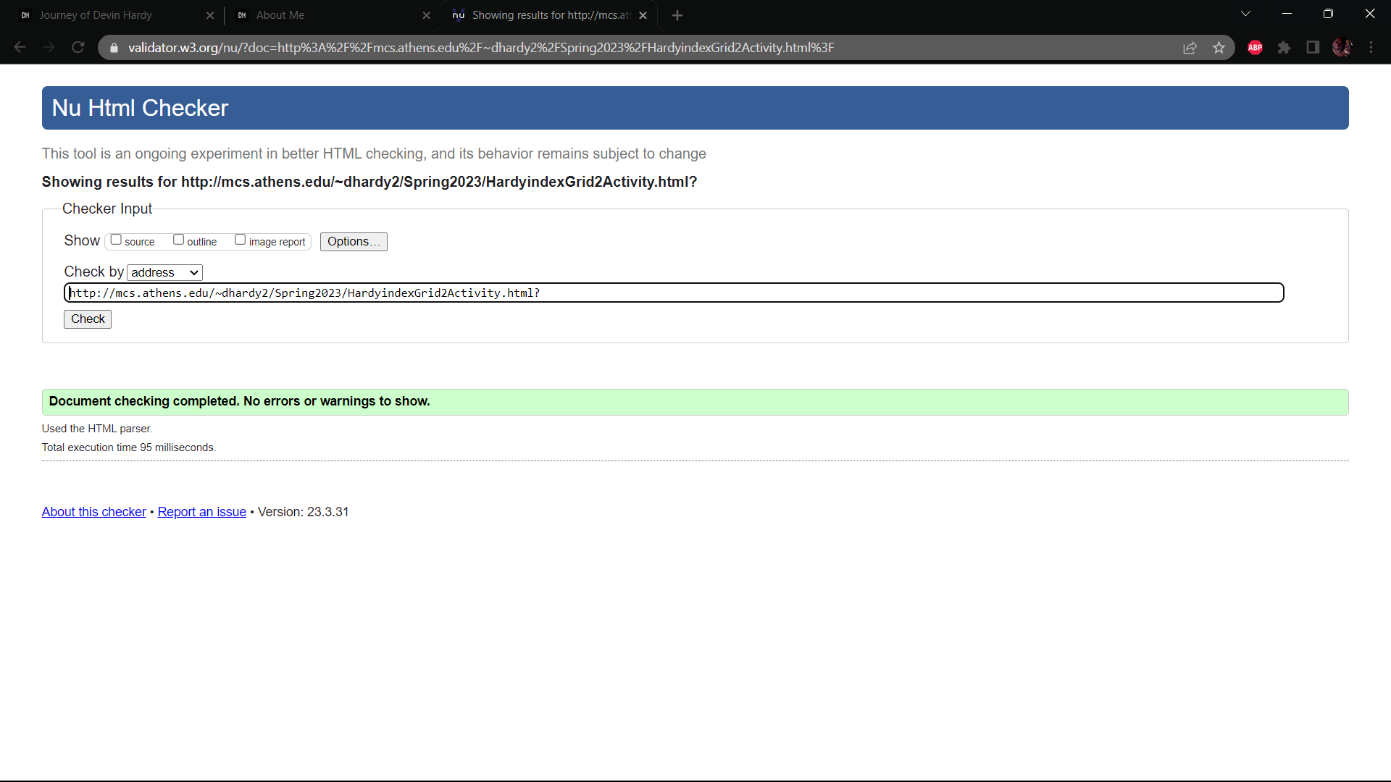

Figure 6.2.11 JS Learning 1 Validation

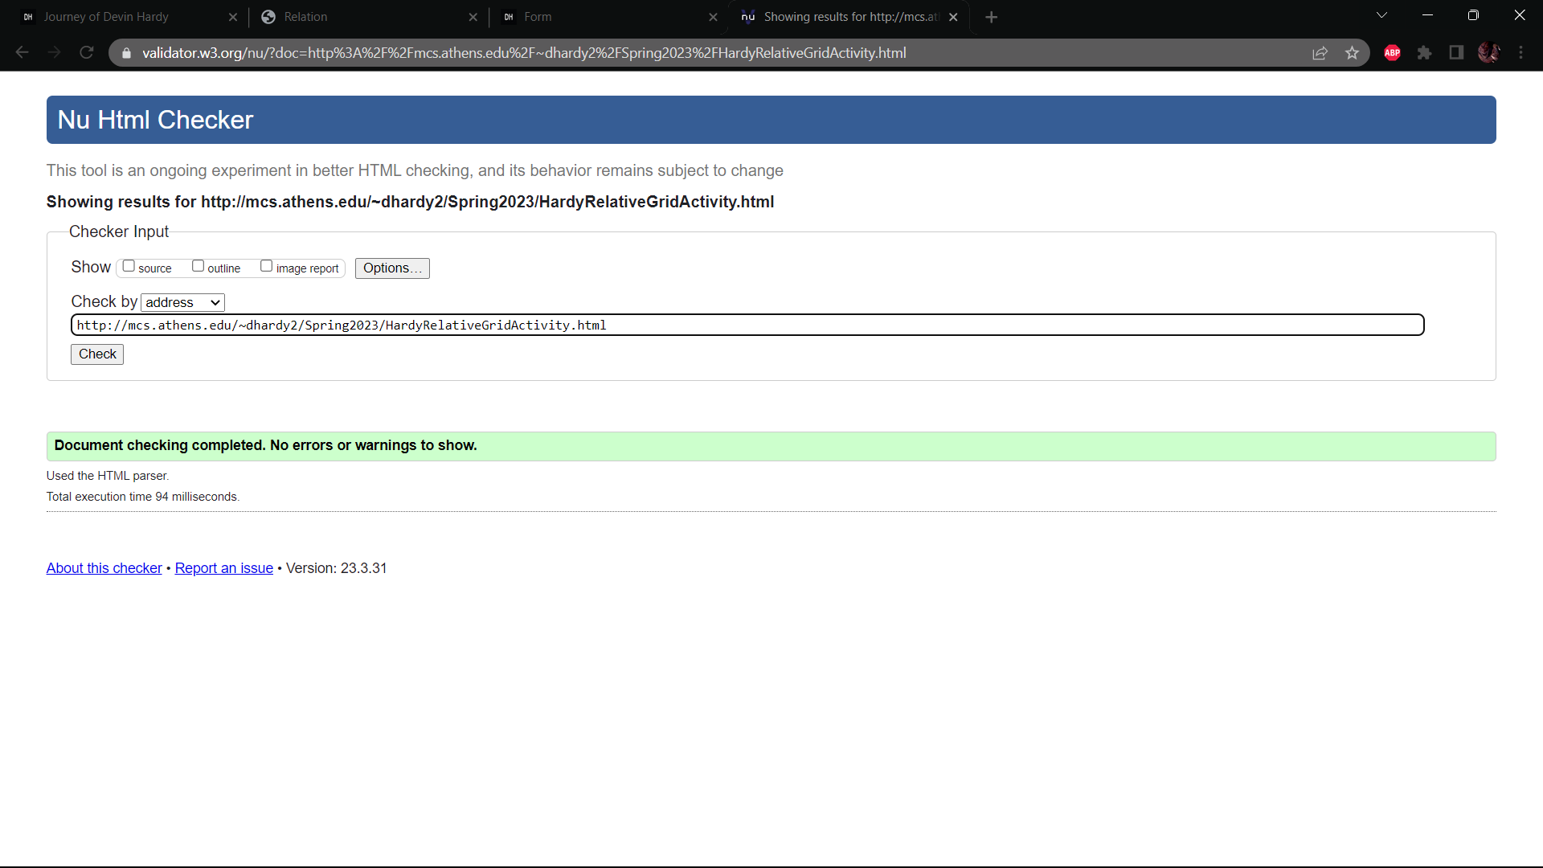

Figure 6.2.12 JS Learning 2 Validation

Figure 6.2.13 JS Learning 3 Validation

Figure 6.2.14 Restaurant V2 Validation

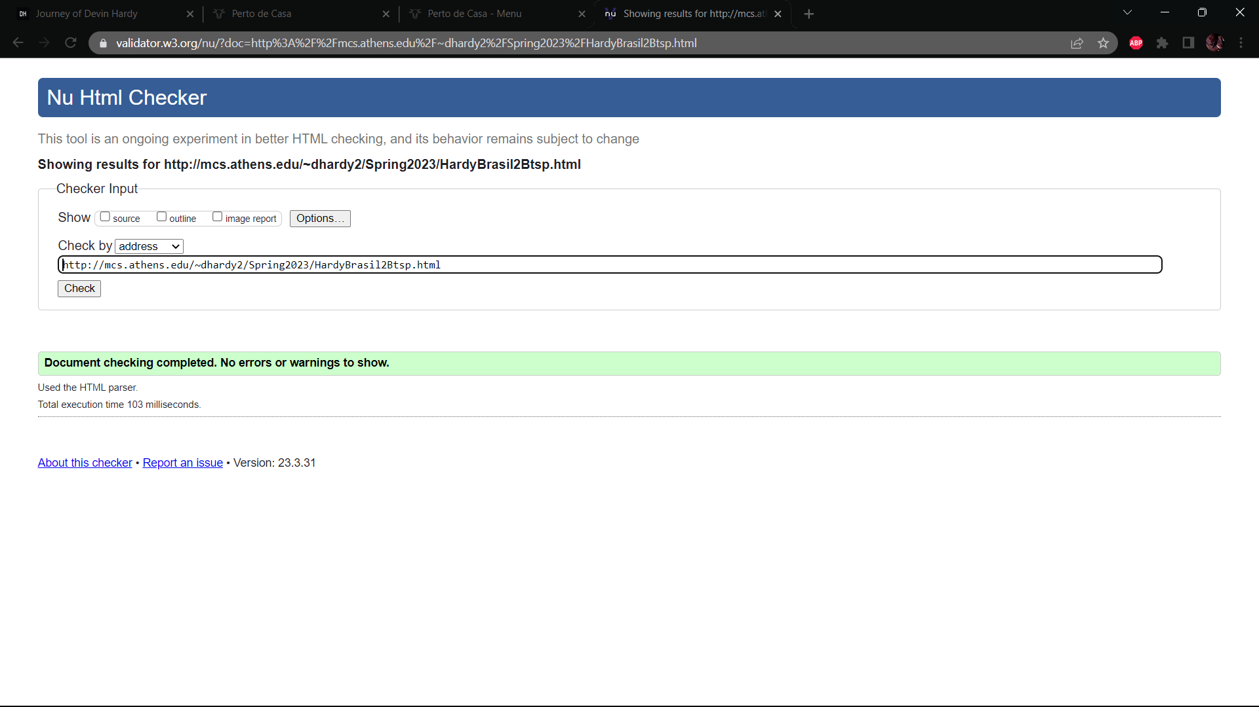

Figure 6.2.15 Menu V2 Validation

# **Accessibility**

## **Web Accessibility**

The site is mostly accessible. There are several alerts related to how the sites were written. There are two errors but those are related to form issues. But since the website doesn’t accept any form data it should be fine as it is so far. The home page of this journey has 3 alerts. Two are related to strange alternative text to images the other is related to skipping heading level 1. My very first webpage holds no errors or alerts as it should with how empty of content it is. My first version of my restaurant has 3 alerts, most of the same as my home page but with the addition of having a redundant link. My first version menu has the alerts of strange alternative text to photos and missing heading level. My midterm project has 3 alerts. The first is missing heading level which I seem to be constantly doing. The other two are related to layout table and the linked YouTube video. When I was learning CSS, JavaScript, and JQuery my sights have the alerts on the YouTube video, strange alternative text to images, and missing fieldset for forms. This is when the error comes where I’m missing a form label. The last alerts are mostly the same as the rest missing heading level and strange alternative text.

My conclusion is that my website is accessible it just has several alerts that could be improved upon that would make it better.

## **Mobile Accessibility**

The mobile accessibility for my website does not exist except on one webpage. The only reasons why my website is not accessible to mobile devices are because the text would be to small to read, it does not have a viewpoint set for mobile devices, and for several pages the clickable elements are clustered too close to each other. The only site of mine that is accessible to mobile is the relative page that has JavaScript where I was learning it. The following figures will show the true or false of the mobile accessibility of my webpages.

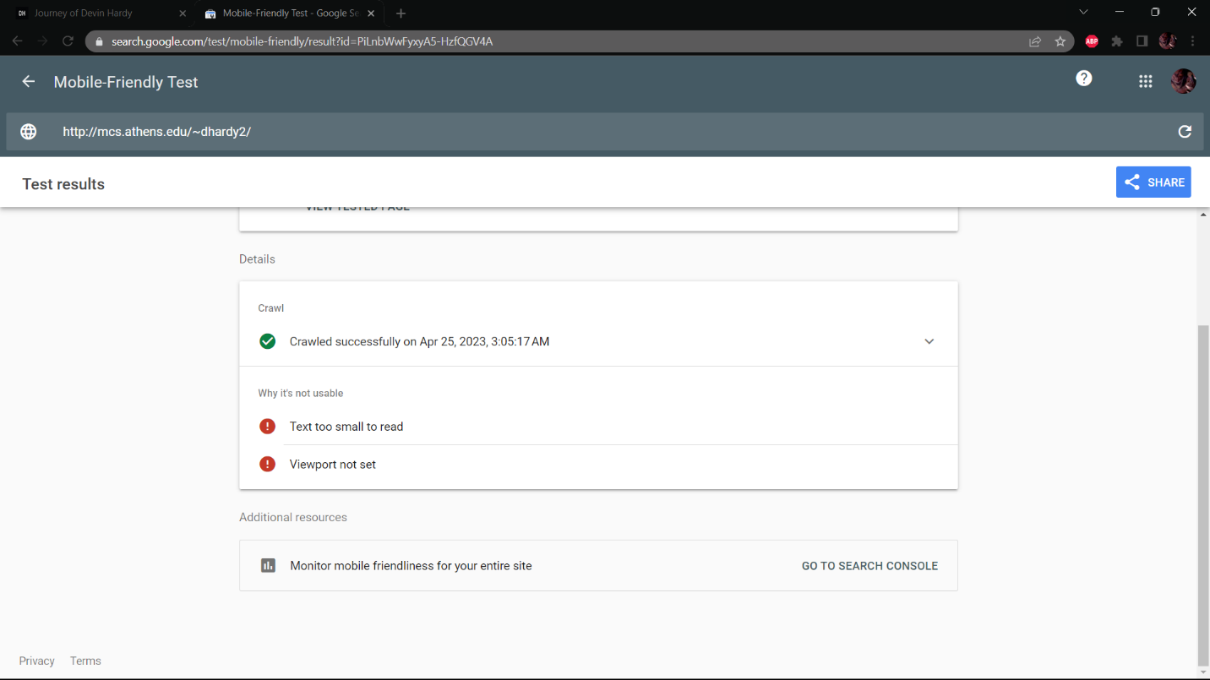

Figure 6.2.1 Home Page Mobile Accessibility

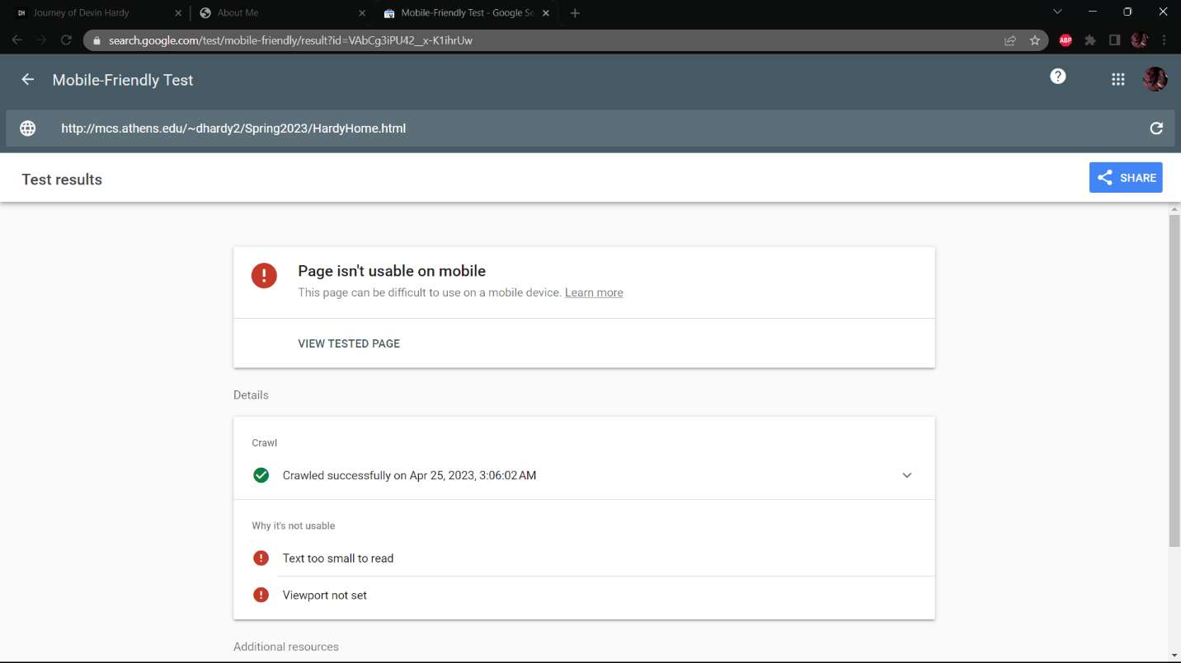

Figure 6.2.2 First Page Mobile Accessibility

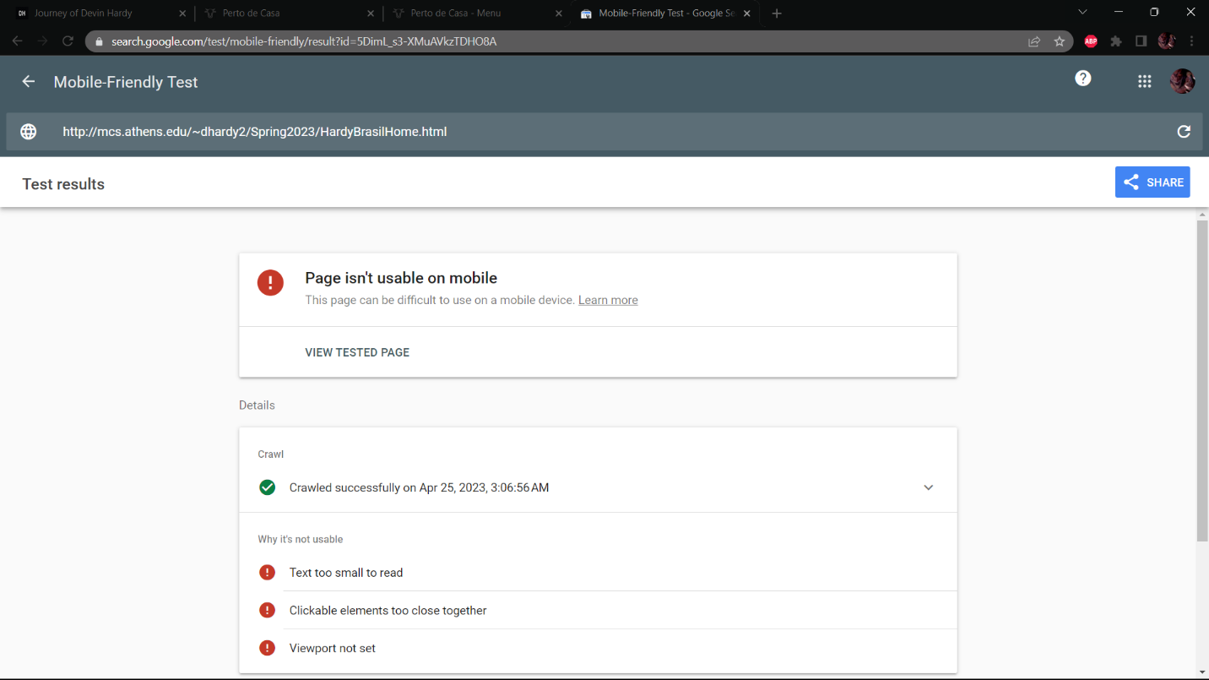

Figure 6.2.3 Restaurant V1 Mobile Accessibility

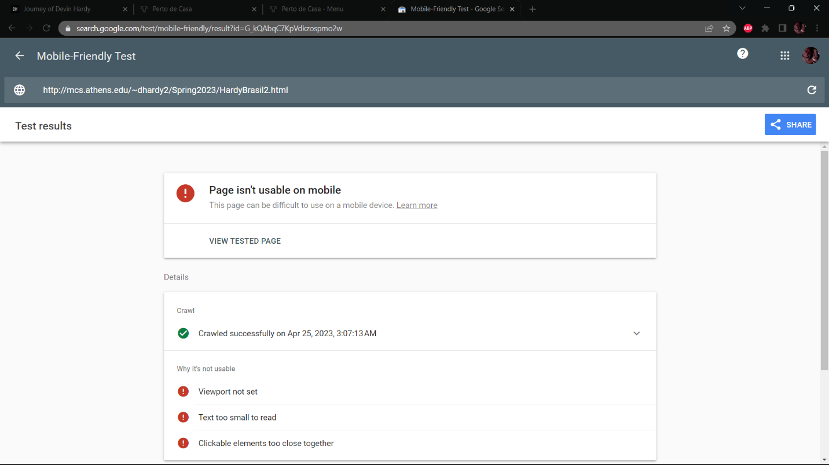

Figure 6.2.4 Menu V2 Mobile Accessibility

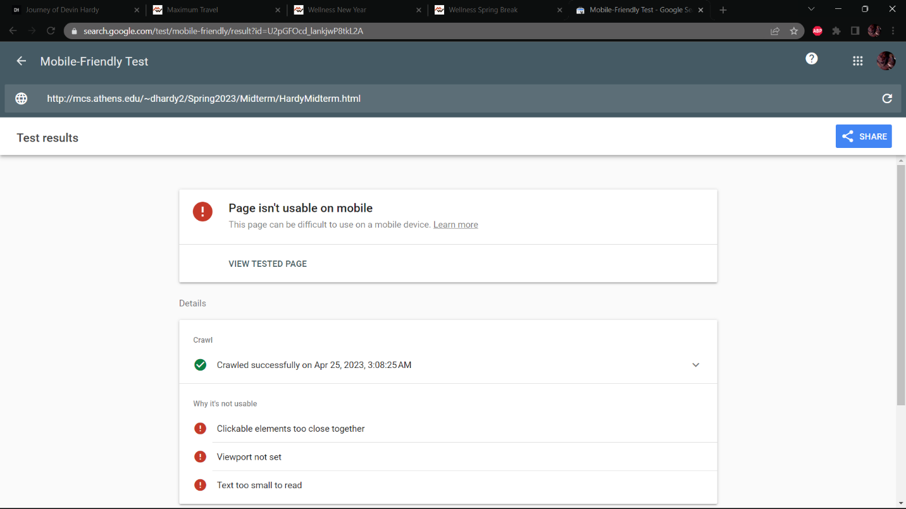

Figure 6.2.5 Midterm Home Mobile Accessibility

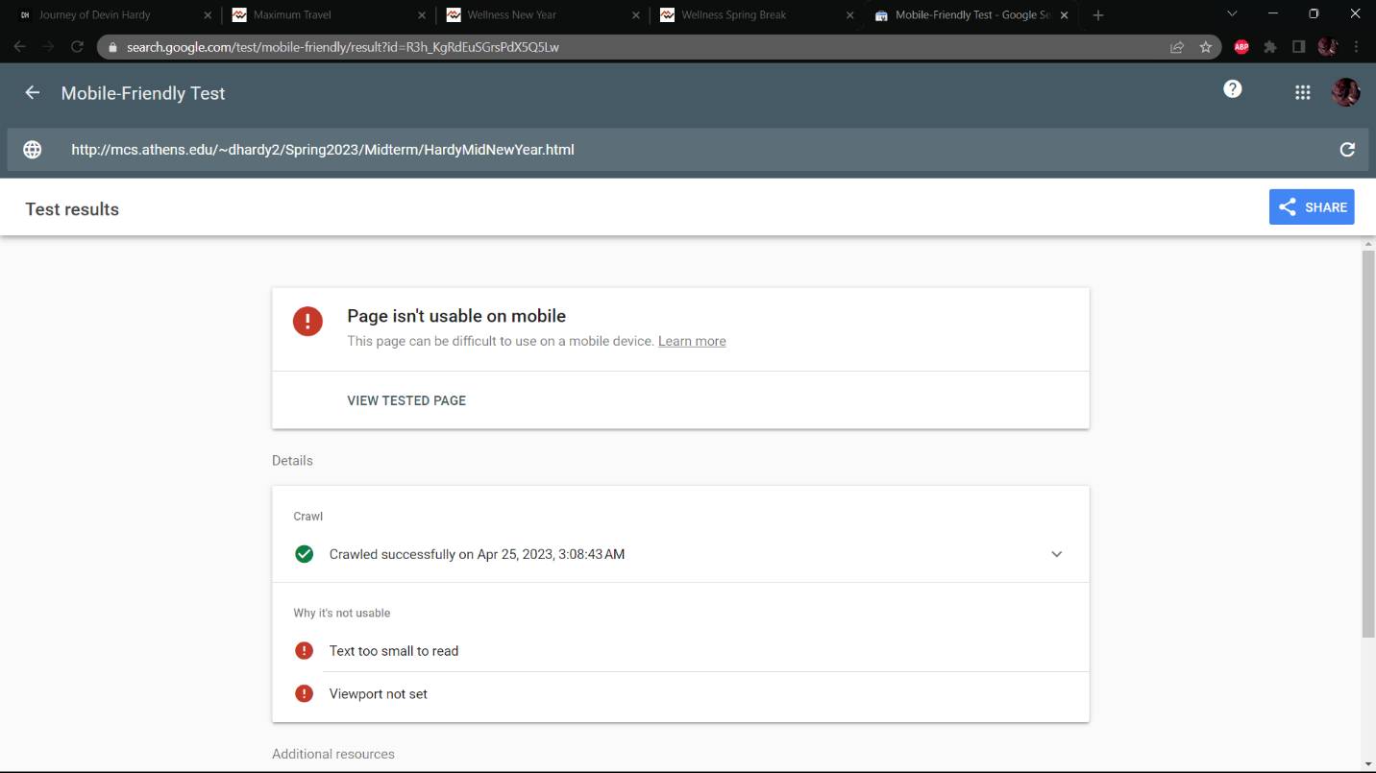

Figure 6.2.6 Midterm New Year Mobile Accessibility

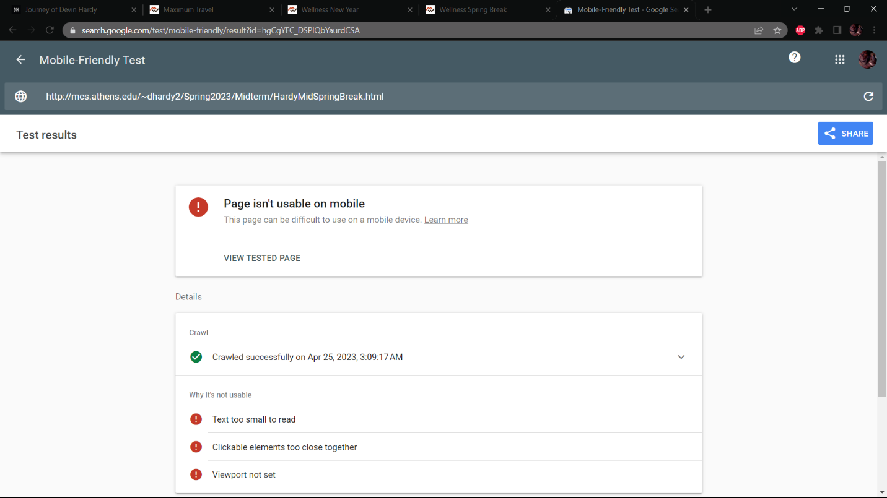

Figure 6.2.7 Midterm Spring Break Mobile Accessibility

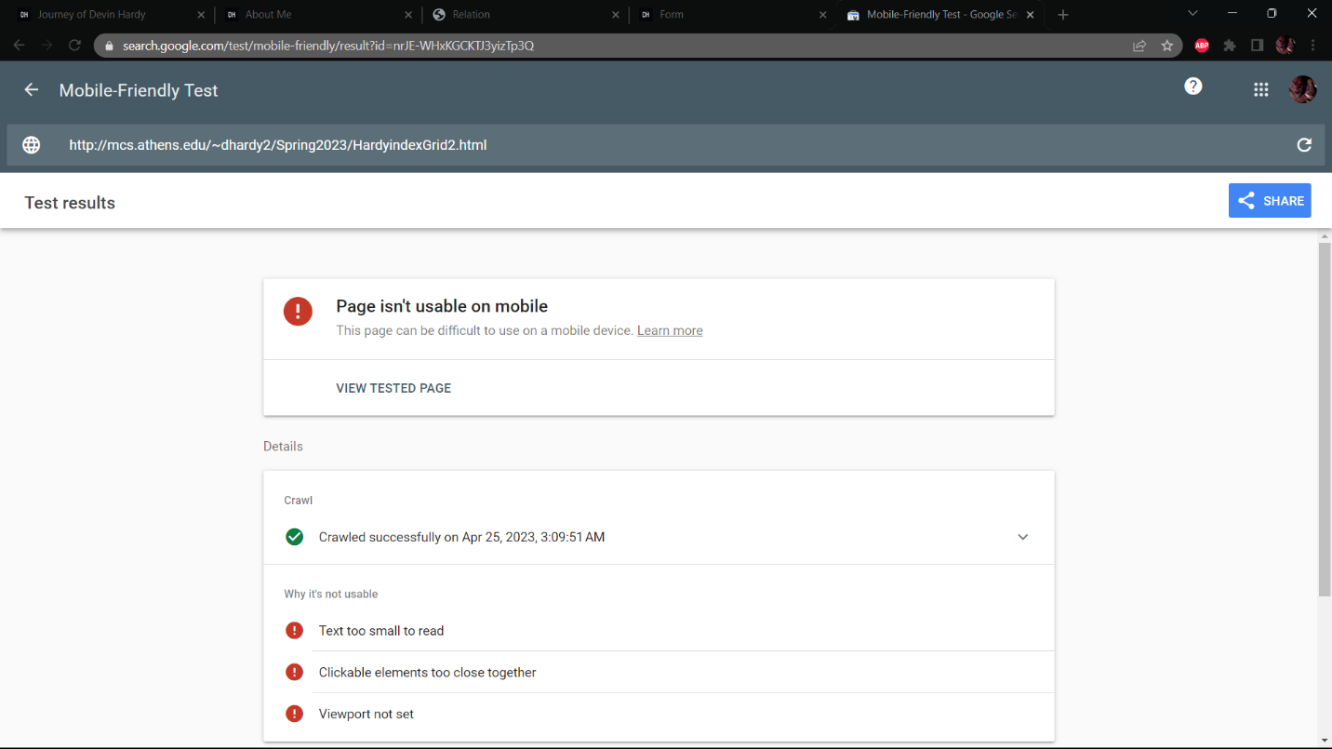

Figure 6.2.8 CSS page 1 Mobile Accessibility

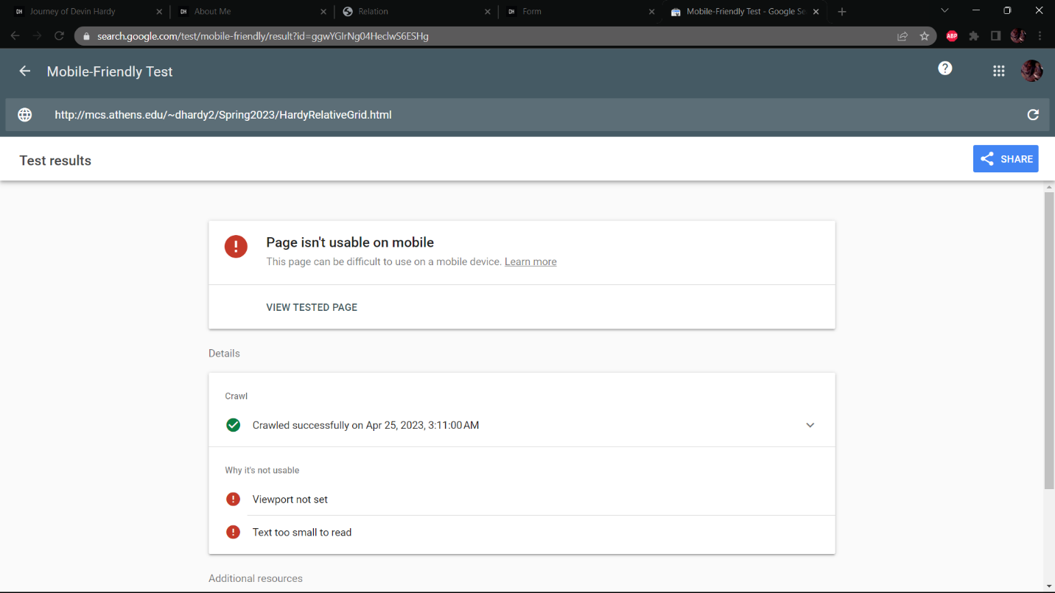

Figure 6.2.9 CSS page 2 Mobile Accessibility

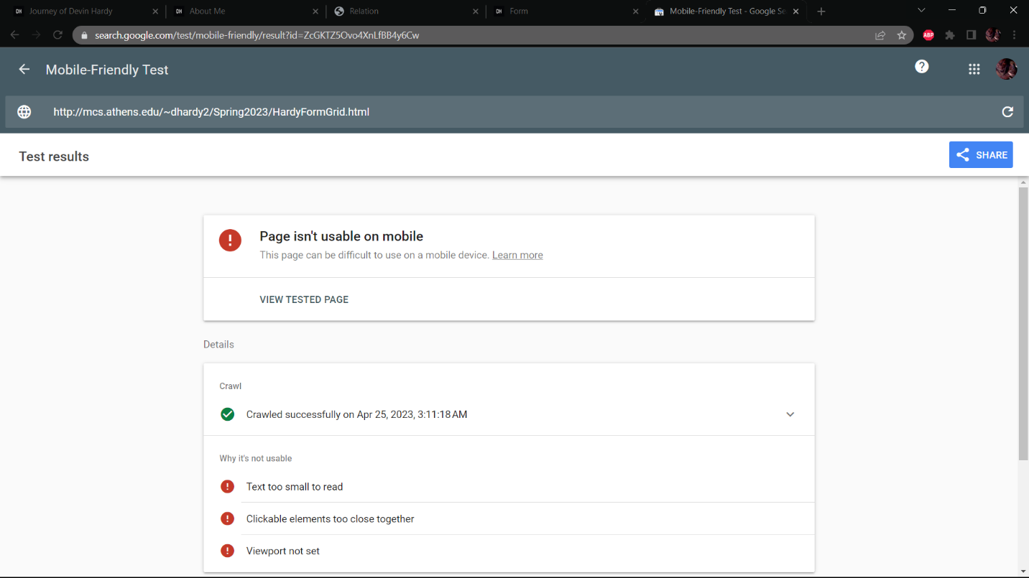

Figure 6.2.10 CSS page 3 Mobile Accessibility

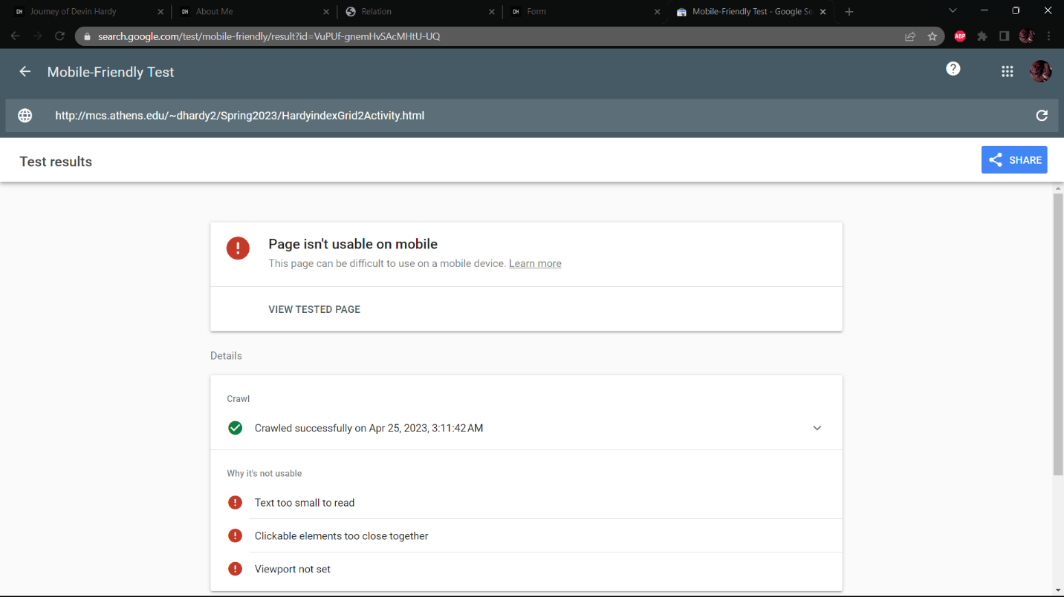

Figure 6.2.11 JS page 1 Mobile Accessibility

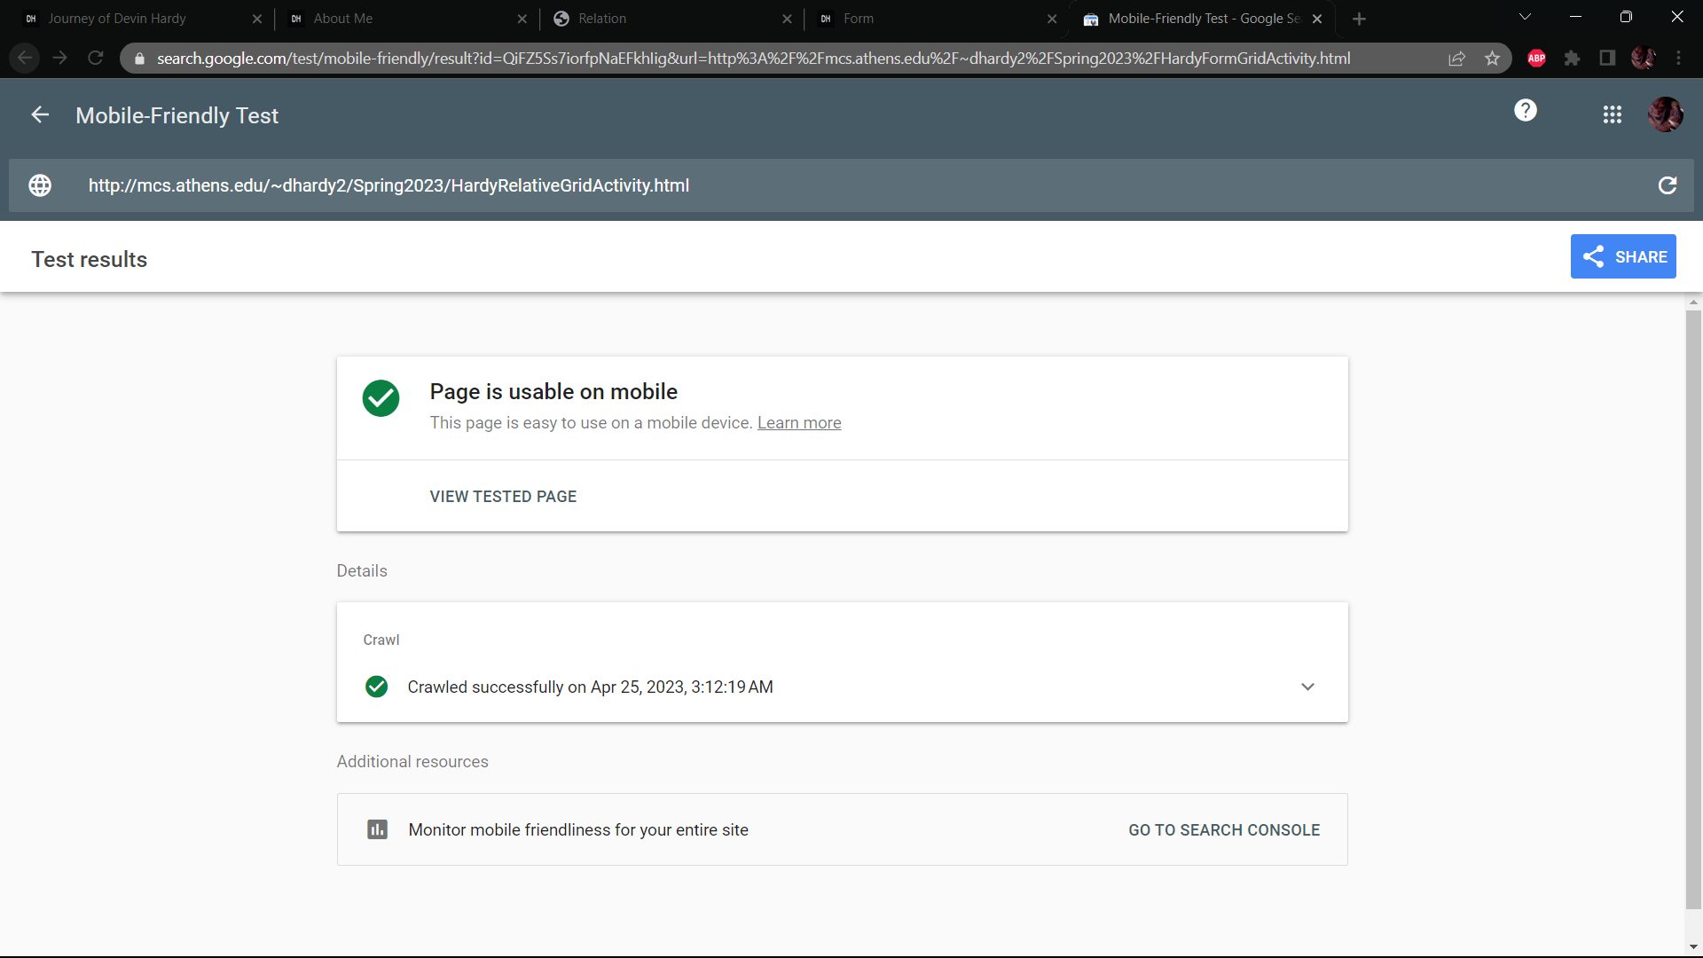

Figure 6.2.12 JS page 2 Mobile Accessibility

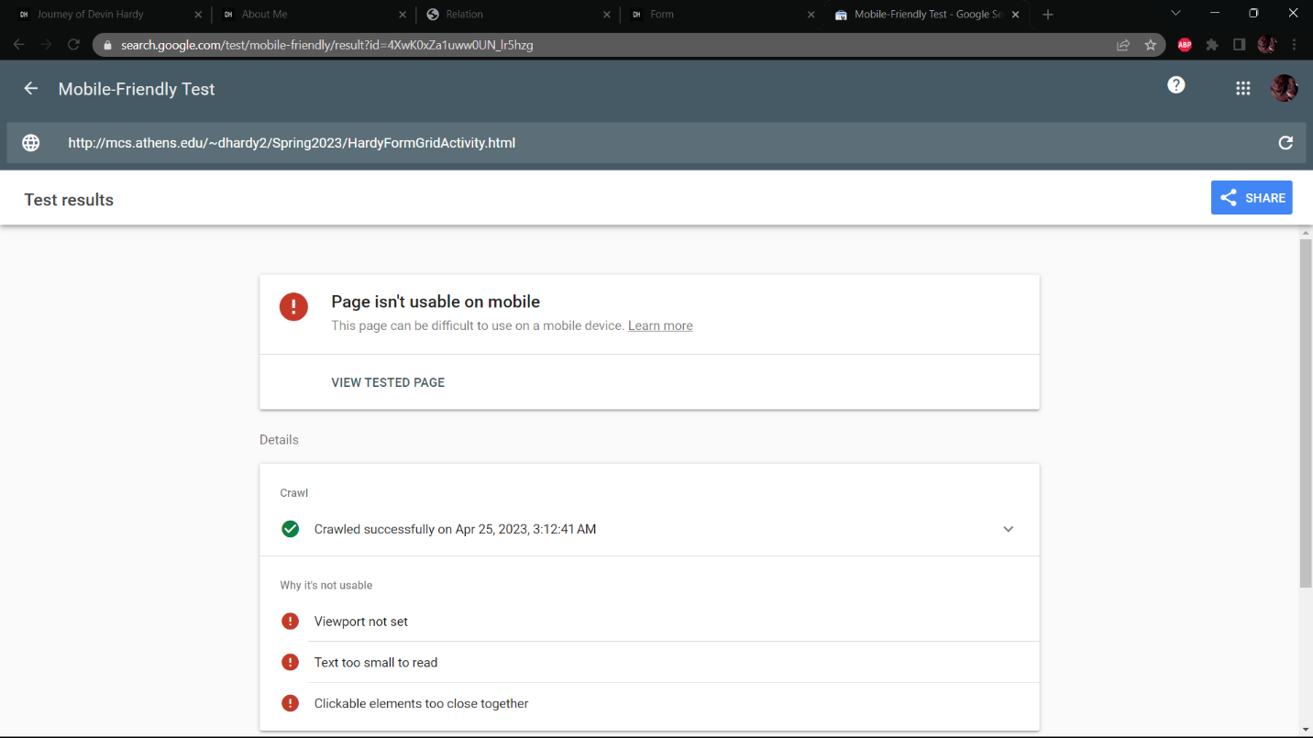

Figure 6.2.13 JS page 3 Mobile Accessibility

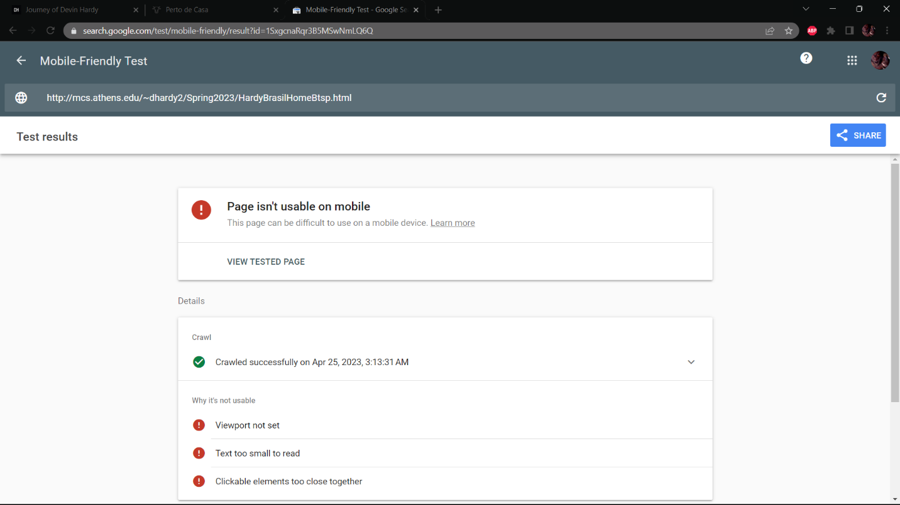

Figure 6.2.14 Restaurant V2 Mobile Accessibility

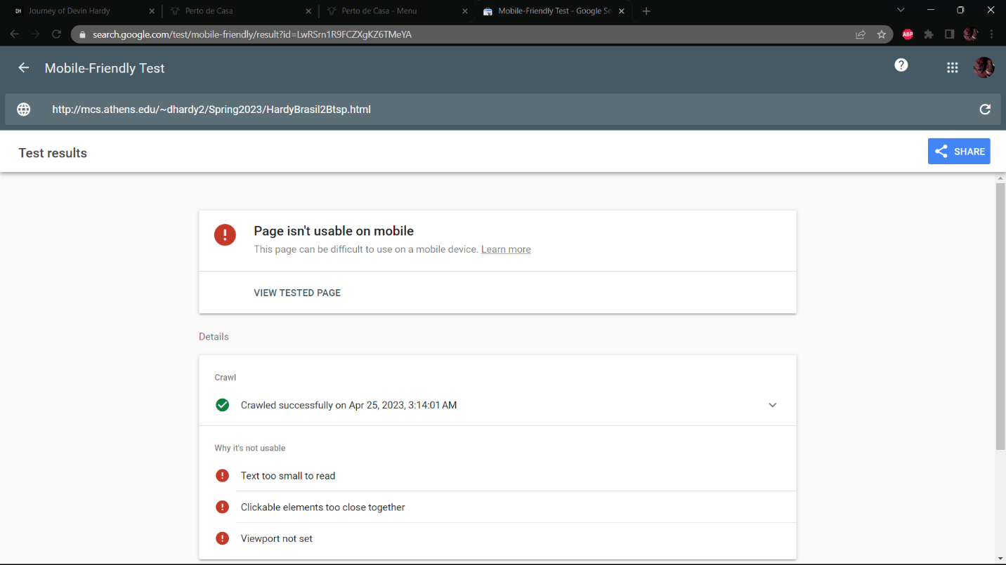

Figure 6.2.15 Menu V2 Mobile Accessibility

# **Reflection**

While learning the content of this course I struggled to be creative. I am not the most creative person so that was my biggest struggle while taking this course. I did enjoy learning the structure and format of making a website and I feel confident I could build basic webpages moving forward. I understand that wireframes are important, but I don’t really use them which makes them about equal to pseudocode to me. Learning the format of HTML felt normal to me, but learning the bit of CSS where I could modify the webpage is a big hurdle that I will continue to struggle with if I continue to build webpages. The addition of JavaScript and JQuery caused an even bigger headache for me since it changes the possibility and structure of how the website. All the possibilities caused me to stress and overthink a lot of the assignment while I had to use them. Luckily there is a bit of a list of things I can do with them that helped me get by. I felt I barely scratched the surface on BootStrap, but I am glad that it has a website on how to use the code for it. I hope to decide one day to experiment with BooStrap to see what all possibilities it holds for making a webpage. However, with the end of the semester I’m confident that I learned a lot and I’m happy to have taken the course.

# **References**

1. “5 easy steps to creating a sitemap for a website,” *QuickSprout*, 07-Mar-2022. [Online]. Available: https://www.quicksprout.com/creating-website-sitemap/. [Accessed: 06-Jun-2022].
2. H. Bhasin, “What is the purpose of a website?,” *Marketing91*, 29-Jul-2018. [Online]. Available: https://www.marketing91.com/purpose-of-a-website/. [Accessed: 06-Jun-2022].
3. “IEEE - referencing guide: Citing in the text,” *Help and Support*. [Online]. Available: https://libguides.murdoch.edu.au/ieee/text. [Accessed: 06-Jun-2022].
4. K. LaGreca, “How to identify stakeholders for your website project,” *NP Group*, 14-Jan-2016. [Online]. Available: https://www.npgroup.net/blog/how-to-identify-stakeholders-for-your-website-project/. [Accessed: 06-Jun-2022].
5. M. Keenan, “What is meta description and how to write one (+examples),” *Shopify*, 10-Dec-2021. [Online]. Available: https://www.shopify.com/blog/how-to-write-meta-descriptions. [Accessed: 06-Jun-2022].
6. R. Allabarton, “The Definitive Guide: How To Make Your First Wireframe,” *6 steps to make your first wireframe [how to guide + video]*, 06-Aug-2021. [Online]. Available: https://careerfoundry.com/en/blog/ux-design/how-to-create-your-first-wireframe/. [Accessed: 06-Jun-2022].
7. “Sitemap Online Generator,” *Create your Google Sitemap Online - XML Sitemaps Generator*. [Online]. Available: https://www.xml-sitemaps.com/. [Accessed: 06-Jun-2022].
8. “The Wicked Easy Way to create a table of contents in word,” *LinkedIn*. [Online]. Available: https://www.linkedin.com/business/learning/blog/productivity-tips/the-wicked-easy-way-to-create-a-table-of-contents-in-word. [Accessed: 06-Jun-2022].
9. “Markup validation service,” *The W3C Markup Validation Service*. [Online]. Available: https://validator.w3.org/. [Accessed: 06-Jun-2022].